Govt. C.L.C. College Patan, dist-durg (C.G.) INDIA
ANNEXURE: 2015-16
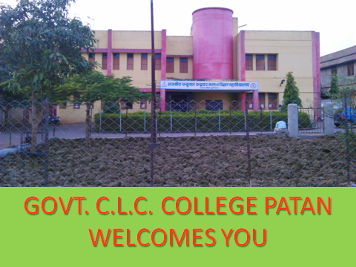
Figure 1 Front look of Govt. C.L.C. College Patan, dist.-Durg (C.G.) 491111 INDIA

LIST OF ANNEXURES
- External evaluation Report 2015-16 of the college, by a team of Higher Education (Annex.-1)
- Annual calender2015-16 downloadable from www.prsu.ac.in (Anex.-2)
- Official letter no.-389/Estt./2015 patan date-18.06.2015 construction of different committee during 2015-16 (Annex.-3)
- A copy of time-table released by the time-table committee headed by Prof. B. M. Sahu, for the session 2015-16 (Annex.-4)
- Red-cross, NSS and NCC activity (Annex.-5)
- Annual demand ratio 2015-16 (Annex.-6)
- Annual drop-out rate 2015-16 (Based on Annual Exam-2016) (Annex.-7)
- Scholarship data (Annex.-8)
- Number of admitted students (Annex.-9)
- Anti-ragging affidavit (for all students, to submit before admission in college (Annex.-10)
- Anti-ragging affidavit for PARENTS of all students (Annex.-11)
- List of NSS “B” and “C” registered students (Annex.-12)
- List of REDCROSS registered students (Annex.-13)
- List of activities in 2015-16 (Annex.-14)
- List of JBS Committee members (Annex.-15)
- Website committee (Annex.-16)
- Result: (a) Annual Exam -2016, (b) Subject-wise Result-2016 (Annex.-17),
- Library enhancement Scheme (Annex.-18)
- Student Feedback data 2015-16 (Annex.-19)
- Feed-back Data of EX. STUDENT, ASSISTANT STAFF (Annexure-20)
- Event Photos of 2015-16 (Annexure-21)
© No part of this FILE can be cited before the prior permission of the college.

ANNEXURE-1
EXTERNAL EVALUATION REPORT 2015-16
Name of the college-Govt. C.L.C. College, Patan, dist.-Durg (C.G.) 491111,
MARKS ALLOTTED TO THE COLLEGE
S.N. | INDICATOR | MAXIMUM MARKS | OBTAINED MARKS
1 | Cleanliness of College-campus/Toilets | 10 | 9
2 | Clean and drinking water for staff and students | 10 | 9
3 | Wi-Fi facilities in college | 10 | 10
4 | Colouring/Greenary/Maintainance of college | 10 | 9
5 | Record keeping/Account maintenance | 10 | 9
6 | Academic work, (including Examination Result) | 10 | 7
7 | NAAC Evaluation | 20 | 15
8 | Placement Cell/ Campus placement | 10 | 5
9 | Canteen, Library, Sports, and other curricular activity | 10 | 7
 | TOTAL | 100 | 80
Members of the External Evaluation Committee, with name and Signature
- Prof. B. M. Sahu (Asstt. Prof. Economics)
- Dr. Sanjay Kumar Das (Asstt. Prof. Geography)
- Harsh Kumar Bhale (President Janbhagidari committee)
- Smt. Nisha Soni (Public representative)
- Sri Sunil Bhale (Guardian representative)
- Ku. Bhawna Dewangan (President, Student Union 2015-16)
- Sri Yogendra Kumar (Secretary, Student Union 2015-16)
Principal
Govt. C.L.C. College Patan, dist.-Durg

Team of Observer, headed by:-Dr. T. C. Gupta, (Prof.), Department of Commerce, Govt. J. Y. (Chhattisgarh) College, Raipur (C. G.)

ANNEXURE-2
Deptt. Of Higher Education, Govt. of Chhattisgarh, Raipur, (C.G.)
Proposed academic calendar for the academic session 2015-16
- Student’s admission procedure (Principal) 16.06.2015-31.07.2015
- Last date of admission (Kulpati permi.) 14.08.2015
- Declaration of Annual examination’s result 15.07.2015
- Declaration of all results of revaluation 30.09.2015
- Conducting supplementary examination In minimum possible time
- Declaration of results of supplementary examinations 31.10.2015
Student Union activity:-
- Construction of student union, Election procedure, Oath: 22.8.15-31.8.15

Sports and Cultural activities:-
- Starting of sports competitions (Indoor, Outdoor) From 16.07.2015
- Completion of sports competitions (Indoor, Outdoor) 20.12.2015
- Games and sports of college level (Indoor, Outdoor)
and prize distribution 20, 22, 23 Dec.2015
(Two days)
N.C.C./N.S.S. and Other activities:-
- Tree plantation program Second week of July 2015
- Camp between 10.10.2015-20.10.2015
- College level annual day Any one day out of 20, 22, 23 Dec.2015
- N.C.C. and N.S.S. Camp 24.12.2015-31.12.2015
- Dikshant Samaroh Month Dec.2015/Jan.2016
Vacations:-
- Dushehara (3 days) 21.10.2015-23.10.2015
- Deepawali (5 days) 10.11.2015-14.11.2015
- Winter vacation (4 days) 24.12.2015-27.12.2015
- Summer vacation (30 days) 16.05.2016-14.06.2016

Internal Examinations:-
- First unit test 31.07.2015
- Second unit test 31.08.2015
- First sessional examination 26, 28, 29 Sept.2015
- Third unit test 03.11.2015
- Second sessional examination 26, 27, 28 Nov.2015
- Fourth unit test 19.12.2015
- Pre-Final examination 22, 23, 24 Jan.2016.

Annual examination program
- Practical examination 16.02.2016—28.02.2016
- Annual examination 01.03.2016—30.04.2016
Monthly working days: Total = 183 days
July-26, Aug-24, Sept-23 days, Oct.-22 days, Nov-19, Dec.-21 days, Jan-25 days, Feb.-23 days

ACADEMIC SCHEDULE FOR SEMESTER COURSE
S.N. | ACTIVITY | SEMESTER- I/III/V/VII | SEMESTER-II/IV/VI/VIII
1 | Admission process | 16 june-30-june 2015 | ----
2 | Commencement of the Classes | 01Jjuly 2015 | 31 December 2015
3 | Meeting. Examination Committee | 04-14 August 2015 | 16—31 Jan 2016
4 | Name of Practical Examiner external) should be to head of S.o.S. | 03—10 Sept 2015 | 21--28 Feb 2016
5 | Completion of Theory Courses | 08 Nov. 2015 | 16 Apr 2016
6 | Practical Examination UG/PG | 15—22 Nov.2015 | 18—30 Apr 2016
7 | Preparation leave | 23—30 Nov.2015 | 01—08 May2016
8 | Theory exam. | 01—24 Dec.2015 | 09—31 May 2016
9 | Semester Break, Declaration of Results | 15—31 Dec.2015 | 01—16 Jun 2016

ANNEXURE-3
Construction of different committee during 2015-16

S.N. | Name of Committee | Convenor  /President | members
1. | Staff council | SS | - |  | - | - |  | - | -
2. | Student Union | SS | RKV |  | SR | SH |  | - | -
3. | AF | Principal | SS |  | BMS | RKV |  | BKC | President and Secretary of Student Union
 |  |  | DN |  | DKT
4. | UGC | SKD | DKB |  | SH | PS |  | - | -
5. | Literacy | RS | PS |  | - | - |  | - | -
6. | Cultural | SR
7 | Library | BMS | JK |  | PS
8 | Purchase | SS | SKD |  | RKV | - |  | - | -
9 | Time-Table | BMS | RKV |  | SR | JK |  | - | -
10 | Right-off | BMS | DKB |  | JK | - |  | - | -
11 | Scholarship | RKV | JK |  | - | - |  | - | -
12 | Internal Audit | UK | MY |  | DC | - |  | - | -
13 | Pay-Fix | BMS | SKD |  | RKV | - |  | - | -
14 | NSS | BMS | JK |  | - | - |  | - | -
15 | NCC | GS | MY |  | - | - |  | - | -
16 | Red-cross | DKB | - |  | - | - |  | - | -
17 | Sports | DN | BMS |  | JK | - |  | - | -
18 | Anti-ragging | SS | RS |  | SKD | JK |  | DN | DKT
19 | Discipline | SS | RS |  | BMS | SKD |  | DKB | RKV
 |  |  | SR |  | JK | SH |  | PS | UK
 |  |  | DN |  | DKT
20 | JBS | SS | BMS |  | RKV | - |  | - | -
21 | AP Appoint. | SS | BMS |  | RKV
22 | SC/ST welfare | JK | SH
23 | RTI | SS | DKB |  | SH
24 | College magazine | RS | RKV |  | SR
25 | BPL Book-Sch | RKV | JK |  | UK | DKT
26 | Ex-Student | SH | RKV
27 | Carrier Guide. | SKD | RKV |  | DKB | SH |  | PS
28 | Lok-Sewa Guarentee | SKD | MY
29 | Inf. And Press | SR | RKV |  | DN
30 | Remedial UGC | Principal | SR |  | UK
31 | Internal Examination | BMS | SR |  | JK
32 | Development | RS | BMS |  | SKD | DKB |  | SH | DKT
33 | Staff-Room | RS | SH
34 | Feed-Back An. | RS | RKV |  | SR | SH |  | PS | UK | RDB*
35 | Environment Awareness | BMS | DKB |  | JK
36 | IQAC | Principal | RKV |  | UK | SR |  | PS | BKC
 |  |  | External members |  |  | Manoj Dewangan |  |  | Sandeep Mishra
38 | RUSA | SAKIL HUSSAIN |  |  |  |  |  |  | RKV
39 | Parent committee | Ex. Student | JBS | Student Union |  |  | Labour | Ex. St. Un. | Parents
40 | Library Navo. | DKT | DN | SR |  |  | JK
41 | Extra-curricu.  e.g.-Quiz, Semi., Debate | RKV | PS | UK
SS=Dr. Shobha Srivastava, BMS=B.M.Sahu, SKD=Dr. S.K.Das, SH=Dr. Shakil Hussain, RS=Rukhmani Sahu, SR=Dr. Sadhna Rahatgaonkar, RKV=Dr. R.K.Verma, JK=Jagrit Kumar, UK=Ugendra Kurrey, PS=Dr. Purnima Seth, DN=Dr. Dinesh Namdev, DKT=Devendra Kumar Tikariha, BKC=Basant Kumar Choubey, MY=Manorama Yadu, RDB*=R.D.Bhuarya-(transferred), JBS=Janbhagidari Samiti, SU=Student Union, GS=Dr. Greeshma Singh, DKB=D.K.Bhardwaj, DC=D.C.Sahu,

ANNEXURE-4

College time-table for the session: 2015-16
COMBINED TIME-TABLE OF U.G. CLASSES and PGDCA
CLASS | ROOM.NO. |  | 10:30-11:00 | 11:00-11:40 | 11:40-12:20 | 12:20-1:00 | 1:00-1:40
B.A.-II | ROOM-3 |  | YOGA | POLITICAL SCI. | GEOGRAPHY | SOCIOLOGY | ECONOMICS
B.A.-III | ROOM-4 |  | YOGA | ECONOMICS | SOCIOLOGY | POLITICAL SCI. | HINDI LIT
B.Sc.-I | ROOM-5 |  | YOGA | CHEMISTRY | PHYSICS | ZOOLOGY | FC.-ENG/  HIN LANG.
B.Sc.-II | ROOM-6 |  | YOGA | MATHS | BOTANY | FC-HIN./ENG. | CHEMISTRY
B.Sc.-III | ROOM-7 |  | YOGA | FC-HIN./ENG. | ZOOLOGY | MATHS | BOTANY
B.COM-I | ROOM-13 |  | YOGA | ACCOUNTING | FC.-HIN./ENG. | BUSINESS MANAGEMENT | EVS-MON, TUE  (Dr. S.H.)  LIB.-WED TO SAT.
B.COM-II | ROOM-12 |  | YOGA | BUSINESS MANAGEMENT | ACCOUNTING | FC-HIN./ENG. LANG | APPLIED  ECONOMICS
B.COM.-III | ROOM-GCR |  | YOGA | FC-HIN./ENG. | INCOM TAX | MARKET. GROUP | AUDITING
1:40-2:20 |  | 2:20-3:00 |  | 3:00-3:40 |  | 3:40-4:20 | 4:20-5:00
POLITICAL SCIENCE |  | SOCIOLOGY |  | EVS-R.K.VERMA |  | PRACT.-GEOG.-(W./TH.) | TUTORIAL
FC.-ENG/HINDI LANG (MON- SAT) |  | HINDI LITERATURE |  | REMEDIAL |  | PRACT.-GEOG.  -(M./TU.) | TUTORIAL
GEOGRAPHY |  | FC-ENG-LANG.  (MON. TO WED.) |  | REMEDIAL |  | PRACT.-GEOG.  -(F./SAT.) | TUTORIAL
MATHS |  | BOT./MATH.-(WED./THUS.)-  SEMINAR HALL |  | PRACTICAL-BOT./ZOOL./  CHEM./PHY. |  | PRACTICAL-BOT.  /ZOOL./CHEM./PHY. | TUTORIAL
PHYSICS |  | ZOOL.  MATH.(FRI., SAT.)  -NEW. LIB |  | PRACTICAL-BOT.  /ZOOL.  /CHEM./PHY. |  | PRACTICAL-BOT.  /ZOOL.  /CHEM./PHY. | TUTORIAL
CHEMISTRY |  | PHYSICS |  | PRACTICAL-BOT./ZOOL.  /CHEM./PHY. |  | PRACTICAL-BOT./  ZOOL./CHEM./PHY. | TUTORIAL  /REMEDIAL
APPLIED ECONOMICS |  | REMEDIAL |  | REMEDIAL |  | TUTORIAL | TUTORIAL
LIBRARY |  | REMEDIAL |  | REMEDIAL |  | TUTORIAL | TUTORIAL
INDIRECT TAX |  | LIBRARY |  | REMEDIAL |  | TUTORIAL | TUTORIAL

TIME TABLE OF P.G.D.C.A.-I, II Semester w.e.f.-July 2015
TIME→  DAY↓ | 10:30-11:00 | 11:00-11:40 | 11:40-12:20 | 12:20-1:00 | 1:00-1:40 | 1:40-2:20 | 2:20-3:00 | 3:00-3:40 | 3:40-4:20 | 4:20-5:00
MON. | YOGA | PGDCA-101 | PGDCA-102 | PGDCA-103 | LIBR.Y | PGDCA-104 | PGDCA-105 | PRACT. | REMED.L | TUTOR.
TUES. | YOGA | PGDCA-101 | PGDCA-102 | PGDCA-103 | LIBR. | PGDCA-104 | PGDCA-105 | PRACT. | REMED. | TUTORI.
WED. | YOGA | PGDCA-101 | PGDCA-102 | PGDCA-103 | LIBRA. | PGDCA-104 | PGDCA-105 | PRACT. | REMEDI. | TUTORI.
THURS. | YOGA | PGDCA-101 | PGDCA-102 | PGDCA-103 | LIBRA. | PGDCA-104 | PGDCA-105 | PRACT. | REMEDI. | TUTORI.
FRI. | YOGA | PGDCA-101 | PGDCA-102 | PGDCA-103 | LIBRA. | PGDCA-104 | PGDCA-105 | PRACT. | REMEDI. | TUTOR.
SAT. | YOGA | PGDCA-101 | PGDCA-102 | PGDCA-103 | LIBRA. | PGDCA-104 | PGDCA-105 | PRACT. | REMEDI. | TUTOR.

TIME→  DAY↓ | 10:30-11:00 | 11:00-11:40 | 11:40-12:20 | 12:20-1:00 | 1:00-1:40 | 1:40-2:20 | 2:20-3:00 | 3:00-3:40 | 3:40-4:20 | 4:20-5:00
MON. | YOGA | PGDCA-106 | PGDCA-107 | PGDCA-108 | LIBR. | PGDCA-109 | PGDCA-110 | PRAC | REMED. | TUTOR.
TUES. | YOGA | PGDCA-106 | PGDCA-107 | PGDCA-108 | LIB. | PGDCA-109 | PGDCA-110 | PRAC | REMED. | TUTOR.
WED. | YOGA | PGDCA-106 | PGDCA-107 | PGDCA-108 | LIB. | PGDCA-109 | PGDCA-110 | PRAC | REMED. | TUTOR.
THURS. | YOGA | PGDCA-106 | PGDCA-107 | PGDCA-108 | LIB. | PGDCA-109 | PGDCA-110 | PRAC | REMED. | TUTOR.
FRI. | YOGA | PGDCA-106 | PGDCA-107 | PGDCA-108 | LIB. | PGDCA-109 | PGDCA-110 | PRAC | REMED. | TUTOR.
SAT. | YOGA | PGDCA-106 | PGDCA-107 | PGDCA-108 | LIB. | PGDCA-109 | PGDCA-110 | PRAC | REMED. | TUTOR.
NOTE- TIME-TABLE OF P.G.-CLASSES HAS BEEN PREPARED BY THE CONCERN DEPARTMENTS. DAYWISE PRACTICAL CLASSES OF UG WILL BE DECIDED BY CONCERNING SUBJECT HODs.

ANNEXURE-5
REDCROSS, NSS AND NCC ACTIVITY DURING 2015-16
  - REDCROSS ACTIVITY
- 06.11.2015 - Blood group checking and health checkup program organized in college. 149 students benefitted. This was helped by primary health centre Patan.
- 23.01.2016 - Blood donation camp organized in college. In this program 26 blood donation were done, including Sports officer Dr. Dinesh Namdev.
- Rally on Voter awareness organized in college.
- First-AID awareness program organized by nursing college Sec.-9, BHILAI
Prof.-D.K. Bhardwaj

  - NSS ACTIVITY
- Special 7-days camp- Held at village Borid, Teh.-Patan, 75 students participated
- Rally on natonal cleanliness day 02.10.2015. Human-chain was made near Akhra temple, Dussahara Ground.
- One day camp organized in villege- Nawagaon, and in village- Changori.
- Kitchen Cooker purchased for cooking foods in camps.

Prof. B. M. Sahu
Prof. Jagrit Kumar

  - NCC ACTIVITY IN 2015-16
- 22 student participated in the 10 days NCC Camp held at Indira Gandhi Agriculture college, Raipur. Out of six group in this camp our get first prize.
- 22 student participated in the Parasailing camp held at Charoda, dist-Durg
- Five students participated in Mats university camp, Raipur.
- Six students received NCC-B certificate in 2016.
- 18 girls participated in Govt. K.C.B. College Bhilai-3 on International Yoga Day held on 21.06.2015
Dr. Greeshma Singh

ANNEXURE-6

THE ANNUAL DEMAND-RATIO ON 2015-16

S.N. | Class / Sem. | No. of application received (x) | Actual New admission (y) | No. of available seats / intake (z) | Demand  Ratio (x/z)
1 | B.A.-I | 417 | 300 | 300 | 1.390
2 | B.SC.-I (M) | 55 | 44 | 60 | 0.91
3 | B.SC.-I (B) | 97 | 60 | 60 | 1.616
4 | B.COM-I | 77 | 54 | 60 | 1.426
5 | M.A.-I Sociology | 20 | 14 | 20 | 1.000
6 | M.A.-I Pol.Sci. | 38 | 18 | 20 | 1.900
7 | M.A.-I Economics | 06 | 05 | 20 | 0.300
8 | M.A.-I Geography | 16 | 07 | 20 | 0.800
9 | M.A.-I Hindi | 26 | 12 | 20 | 1.300
10 | M.Sc.-I Chemistry | 100 | 20 | 20 | 5.000
11 | M.Sc.-I Botany | 90 | 20 | 20 | 4.500
12 | M.Sc.-I Zoology | 92 | 20 | 20 | 4.600
13 | PGDCA-I sem. | 117 | 35 | 35 | 3.343
 | TOTAL | 1151 | 609 | 675 | 1.8899

ANNEXURE-7

THE ANNUAL DROP-OUT RATE ON 2015-16
(Based on Result of Annual Exam*-2016)

S.N. | Class | Admitted in UG:2013-14,  or in PG:  2014-15 = (p) | Pass in final exam, 2015-16 received  degree = (q) | Drop-out value, i.e., difference of admitted and pass-out = (r=p-q) | Drop-out rate  (= r/p)  Drop-out  percent = 100(r/p)
1 | B.A.-I | 254 | 169 | 85 | 0.334 (33.46%)
2 | B.SC.-I (M+B) | 119 | 36 | 83 | 0.697 (69.74%)
4 | B.COM-I | 48 | 00 | 48 | 1.00 (100%)
5 | M.A.-I Sociology | 19 | 13 | 6 | 0.315 (31.58%)
6 | M.A.-I Pol.Sci. | 20 | 13 | 7 | 0.3500 (35%)
7 | M.A.-I Economics | 10 | 8 | 2 | 0.200 (20.00%)
8 | M.A.-I Geography | 11 | 10 | 1 | 0.0909 (9.09%)
9 | M.A.-I Hindi | 6 | 4 | 2 | 0.333 (33.33%)
10 | M.Sc.-I Chemistry | 20 | 13 | 7 | 0.35 (35%)
11 | M.Sc.-I Botany | 20 | 18 | 2 | 0.1 (10%)
12 | M.Sc.-I Zoology | 20 | 19 | 1 | 0.05 (5.oo%)
13 | PGDCA-I sem. (2015-16) | 35 | 30 | 5 | 0.142 (14.28%)
 | TOTAL | 582 | 333 | 249 | 0.427 (42.78%)

ANNEXURE-8
GOVT. SCHOLARSHIP DATA 2015-16
Online Post-Metric SC/ST/OBC Scholarship
S.N. | category | NEW | Re-New | Total
1 | SC | 61 | 35 | 96
 |  | 2,82,905=00 | 1,40,405=00 | 423310=00
2 | ST | 31 | 18 | 49
 |  | 1,29,470=00 | 84,170=00 | 213640=00
3 | OBC | 360 | 328 | 688
 |  | 7,28,730=00 | 6,51,976=00 | 1380706=00
TOTAL | Benefitted Rs. | 452 | 381 | 833
 |  | 1141105=00 | 876551=00 | 2017656=00

B.P.L. SCHOLARSHIP 2015-16
S.N. | UG |  |  | PG
 | ARTS | SCIENCE | COMMERCE | ARTS | SCIENCE
No. of benefitted | 49 | 21 | 06 | 22 | 18
Amount | 3,67,200=00 (Three lacs sixty seven thousand two hundred only)

Online minority SCHOLARSHIP 2015-16
06 proposals were submitted in this college, which has been forwarded to the minority commission.
Online merit SCHOLARSHIP 2015-16
12 proposals were submitted in this college, which has been sent to the Chhattisgarh madhyamic siksha mandal Raipur, (C.G.)

ANNEXURE-9
NUMBER OF STUDENTS IN 2015-16 as on date:31.01.2016
NUMBER OF ADMITTED STUDENTS IN 2015-16
S.N. | CLASS | G-B | G-G | G-T | C-B | C-G | C-T | T-B | T-G | T-T | B-B | B-G | B-T | Tot-B | Tot-G | Tot-T
1 | B.A.-1 | 6 | 11 | 17 | 18 | 18 | 36 | 12 | 14 | 26 | 81 | 139 | 220 | 117 | 183 | 300
2 | B.A.-2 | 2 | 6 | 8 | 7 | 10 | 17 | 4 | 4 | 8 | 53 | 130 | 183 | 66 | 150 | 216
3 | B.A.-3 | 1 | 2 | 3 | 6 | 11 | 17 | 2 | 4 | 6 | 35 | 66 | 101 | 44 | 83 | 127
4 | B.SC.-1 | 0 | 1 | 1 | 7 | 9 | 16 | 2 | 7 | 9 | 27 | 51 | 78 | 36 | 68 | 104
5 | B.SC.-2 | 0 | 1 | 1 | 2 | 4 | 6 | 1 | 1 | 2 | 18 | 29 | 47 | 22 | 35 | 57
6 | B.SC.-3 | 0 | 1 | 1 | 0 | 3 | 3 | 0 | 1 | 1 | 5 | 27 | 32 | 5 | 32 | 37
7 | B.COM.-1 | 3 | 4 | 7 | 3 | 3 | 6 | 1 | 1 | 2 | 19 | 18 | 37 | 27 | 26 | 53
8 | B.COM-2 | 1 | 0 | 1 | 2 | 0 | 2 | 1 | 0 | 1 | 7 | 9 | 16 | 11 | 9 | 20
9 | B.COM-3 | 0 | 0 | 0 | 0 | 0 | 0 | 0 | 0 | 0 | 6 | 3 | 9 | 6 | 3 | 9
10 | M.A.-I (SOCIO.) | 1 | 0 | 1 | 0 | 0 | 0 | 0 | 0 | 0 | 3 | 11 | 14 | 4 | 11 | 15
11 | M.A.-III (SOC.) | 1 | 0 | 1 | 0 | 1 | 1 | 2 | 1 | 3 | 9 | 2 | 11 | 12 | 4 | 16
12 | M.A.-I (POL. SCI.) | 0 | 0 | 0 | 1 | 2 | 3 | 1 | 0 | 1 | 6 | 8 | 14 | 8 | 10 | 18
13 | M.A.-III (POL.SCI.) | 0 | 0 | 0 | 0 | 0 | 0 | 2 | 1 | 3 | 2 | 8 | 10 | 4 | 9 | 13
14 | M.A.-I (ECONO.) | 0 | 0 | 0 | 0 | 0 | 0 | 0 | 0 | 0 | 0 | 5 | 5 | 0 | 5 | 5
15 | M.A.-III (ECONO.) | 1 | 1 | 2 | 0 | 0 | 0 | 0 | 0 | 0 | 3 | 3 | 6 | 4 | 4 | 8
16 | M.A.-I (GEOGR.) | 0 | 1 | 1 | 0 | 1 | 1 | 0 | 0 | 0 | 4 | 1 | 5 | 4 | 3 | 7
17 | M.A.-III (GEOGR.) | 0 | 0 | 0 | 0 | 0 | 0 | 0 | 3 | 3 | 4 | 3 | 7 | 4 | 6 | 10
18 | M.A.-I (HINDI) | 0 | 0 | 0 | 0 | 1 | 1 | 0 | 0 | 0 | 5 | 6 | 11 | 5 | 7 | 12
19 | M.A.-III (HINDI) | 0 | 0 | 0 | 0 | 2 | 2 | 0 | 0 | 0 | 1 | 2 | 3 | 1 | 4 | 5
20 | M.SC.-I (BOT.) | 0 | 0 | 0 | 1 | 3 | 4 | 0 | 0 | 0 | 5 | 11 | 16 | 4 | 16 | 20
21 | M.SC.-III (BOT.) | 0 | 0 | 0 | 0 | 0 | 0 | 0 | 0 | 0 | 10 | 8 | 18 | 8 | 10 | 18
22 | M.SC.-I (CHEM.) | 0 | 3 | 3 | 0 | 3 | 3 | 1 | 0 | 1 | 3 | 10 | 13 | 6 | 14 | 20
23 | M.SC.-III (CHEM.) | 1 | 1 | 2 | 1 | 1 | 2 | 0 | 0 | 0 | 6 | 8 | 14 | 10 | 8 | 18
24 | M.SC.-I (ZOOL) | 1 | 0 | 1 | 1 | 1 | 2 | 1 | 1 | 2 | 6 | 9 | 15 | 9 | 11 | 20
25 | M.SC.-III (ZOOL) | 0 | 1 | 1 | 1 | 1 | 2 | 1 | 0 | 1 | 4 | 10 | 14 | 7 | 12 | 19
26 | PGDCA-I SEM | 1 | 0 | 1 | 3 | 5 | 8 | 1 | 0 | 1 | 10 | 15 | 25 | 15 | 20 | 35
TOTAL |  | 19 | 33 | 52 | 53 | 79 | 132 | 32 | 38 | 70 | 332 | 592 | 924 | 439 | 743 | 1182
Abbreviation: G-B = General-Boys, G-G = General-Girls, G-T = General-Total, C-B = SC-Boys, C-G = SC-Girls, C-T = SC-Total, T-B = ST-Boys, T-G = ST-Girls, T-T = ST-Total, B-B = OBC-Boys, B-G = OBC Girls, B-T = OBC-Total, Tot-B = Total-Boys, Tot-G = Total-Girls, Tot-T = Total of Totals

ANNEXURE-10
ANTI-RAGGING AFFIDAVIT FOR ALL STUDENTS, TO BE ADMITTED IN THE COLLEGE

ANNEXURE-11
ANTI-RAGGING AFFIDEVIT FOR THE PARENT OF STUDENT

ANNEXURE-12
REGISTRATION ON 2015-16 FOR N.S.S. B-CERTIFICATE

S.N. | NAME | FATHER’S NAME | CLASS | CATEG | BLOOD GROUP
1 | KU. KIRAN | GOPICHAND | B.A.-I | OBC
2 | ASHWANI | GANESH RAM | B.A.-II | OBC
3 | DEEPAK | SANT RAM | B.A.-II | OBC | B+
4 | EVAN DAS | MANIK DAS | B.A.-II | OBC | B+
5 | CHIMMAN LAL | MEHATTAR PATEL | B.A.-II | OBC | B+
6 | TILESH KUMAR | PILA RAM | B.A.-II | OBC | B+
7 | TIKESHWARI CHANDRAKAR | KAMDEV CHANDRAKAR | B.A.-I | OBC
8 | HARISH KUMAR VERMA | NAND KUMAR | B.A.-I | OBC
9 | VIKASH | BHARAT LAL | B.A.-III | OBC
10 | VIJENDRA KUMAR | GHANSHYAM | B.A.-II | OBC
11 | DEV BRAT | PAWAN KUMAR | B.A.-III | OBC
12 | UMESH DEWANGAN | KARTIK RAM | B.Sc.-I | OBC
13 | CHITRANGAD DEWANGAN | SANTOSH DEWANGAN | B.Sc.-I | OBC
14 | KU. MENKA PATEL | KESHAV RAM | B.A.-II | OBC
15 | KU. DEVKI YADAV | ARJUN SINGH | B.A.-I | OBC
16 | MAHESH KUMAR | MANOJ KUMAR | B.Sc.-I | SC
17 | HEMCHAND | HEMANT KUMAR | B.Sc.-III | OBC
18 | SANJAY NISHAD | DHANSINGH | B.A.-I | OBC | O-
19 | BHASKAR VAISHNAV | GAJENDRA VAISHNAV | B.SC.-I | OBC
20 | AJAY KUMAR | RAM NARAYAN | B.A.-I | OBC
21 | KU. SABBU | KEJU RAM | B.A.-I | SC | B+
22 | KU. USHA PATEL | ROHIT PATEL | B.A.-I | OBC
23 | KU. PRIYANKA SAHU | EMESHWAR | B.SC.-I | OBC | O+
24 | HEMLATA SAHU | DWARIKA PRASAD | B.A.-I | OBC
25 | KU. RINA NAYAK | SOHAN LAL | B.A.-I | OBC
26 | KU. TOSHI VERMA | ARJUN VERMA | B.A.-II | OBC
27 | KU. PADMA PATEL | CHUNNU LAL | B.A.-II | OBC
28 | VIVEK VERMA | KAMLESH VERMA | B.SC.-I | OBC
29 | REWA RAM | RAMENDRA YADAV | B.A.-I | OBC
30 | MOHAN | CHARAN | B.A.-I | OBC | O+
31 | LOKNATH SAHU | SANT RAM | B.A.-I | OBC | O+
32 | KU. PAYAL VERMA | DHANI RAM | B.SC.-I | OBC
33 | KU. DHATRI SAHU | REWA RAM | B.A.-I | OBC | O+
34 | KU. SARASWATI SAHU | VISHNU SAHU | B.A.-I | OBC
35 | JAYA SAHU | JAGANNATH SAHU | B.A.-I | OBC
36 | CHANDRASHEKHAR | RAM PRASAD | B.SC.-I | OBC
37 | NAGENDRA KUMAR | KHILAWAN VISWAKAR. | B.SC.-I | OBC
38 | PRADEEP KUMAR | KEDAR | B.SC.-I | SC | AB+
39 | UMESH KUMAR | MANI RAM | B.SC.-I | SC
40 | RAHUL BANCHHOR | ROHIT BANCHHOR | B.SC.-I | OBC
41 | KU. ANJU | BALA RAM | B.A.-I | OBC
42 | KU. TANUJA SAHU | DHANNU RAM | B.A.-I | OBC
43 | KU. PREETI YADAV | BALDAU YADAV | B.A.-I | OBC
44 | DEEPMALA DEWANGAN | SHESH RAM | B.A.-I | OBC
45 | KU.MAMTA SAHU | ASHWANI KUMAR | B.SC.-I | OBC
46 | KU. SHILA NIRMALKAR | TULA RAM | B.A.-I | SC
47 | KU. JANKI THAKUR | PRAHALAD | B.SC.-I | OBC
48 | KU. PUNAM SAHU | DWARIKA PRASAD | B.A.-I | OBC
49 | KU. LEESHU VERMA | KHORBAHRA RAM | B.A.-II | OBC
50 | KU. KHUSHI VERMA | KHORBAHRA VERMA | B.A.-I | OBC
51 | INDU RAMVERMA | SUKDEV VERMA | B.A.-I | OBC
52 | KU. TRIVENI SAHU | GAIND LAL | B.A.-I | OBC
53 | DOMAR | TOPU RAM | B.A.-I | OBC
54 | KHILESH KUMAR | GOVIND RAM | B.A.-I | OBC
55 | KU. NEETU THAKUR | TORAN SINGH | B.A.-I | ST
56 | KU. GAYATRI THAKUR | NAKUL RAM | B.A.-I | OBC
57 | KU. JYOTI VERMA | PAWAN KUMAR | B.A.-I | OBC
58 | PREETAM KUMAR | RAMKHILAWAN | B.A.-II | OBC
59 | KU. PRIYA SHARMA | SURESH KUMAR | B.A.-I | GEN
60 | KU. VERSHA VERMA | VIRENDRA KUMAR | B.COM-I | OBC
61 | MANOJ KUMAR | JAGESHWAR | B.A.-I | OBC
62 | TIKESH KUMAR | PANCH RAM | B.SC.-I | OBC
63 | TILOCHAN SINHA | SUMER | B.SC.-I | OBC
64 | PRAVEEN KUMAR | KATELU RAM | B.A.-I | SC
65 | KU. BHARTI VERMA |  | B.A.-I | OBC
66 | KU. MANISHA VERMA | BALDAU VERMA | B.SC-I | OBC
67 | KU. BINDESHWARI PATEL | MAKHAN LAL | B.A.-I | OBC
68 | KU. KALYANI PATEL | DILIP PATEL | B.A.-I | OBC
69 | KU. MANISHA SAHU | KHAMHAN SAHU | B.COM-I | OBC
70 | KU. TARINI | REKHRAM | B.A.-I | OBC
71 | KU. NIDHI VERMA | SHIV KUMAR | B.A.-I | OBC
72 | KU. RENUKA SAHU | DHANESHWAR SAHU | B.A.-II | OBC
73 | KU. PUJA JALCHHATRI | SANTOSH | B.A.-I | OBC
74 | KU. SHANTI KOSRE | KOMAL SINGH | B.A.-I | SC
75 | LOKESHRARI SAHU | ROHIT KUMAR | B.SC.-I | OBC
76 | KU. JAYATHAKUR | ASHOK KUMAR | B.SC.-I | ST
77 | SUNIL GOSHWAMI | GOVERDHAN | B.A.-I | OBC
78 | KU. USHA SAHU | JIVAN LAL SAHU | B.A.-I | OBC
79 | TIKESH KUMAR | PANCH RAM | B.SC.-I | OBC
80 | KU. OGESHWARI SAHU | ANAND RAM | B.A.-I | OBC
81 | PUSHPENDRA VERMA | KAMDEV VERMA | B.A.-II | OBC
82 | KU. REENESHWARI SAHU | TEN SINGH | B.A.-II | OBC
83 | KU. DIKESHWARI VERMA | KAILASH VERMA | B.A.-I | OBC
84 | KU. JYOTI VERMA | BALRAM SINGH VERMA | B.A.-I | OBC
85 | KU. BABITA YADU | RAMSWARUP YADU | B.A.-I | OBC
86 | MUKESH KUMAR | CHHANNULAL SAHU | B.COM.-I | OBC
PROF. B.M.SAHU
(PROGRAM OFFICER)

REGISTRATION FOR N.S.S. B-CERTIFICATE

S.N. | NAME | FATHER’S NAME | CLASS | CATEG | BLOOD GROUP
1 | MAHENDRA PATEL | PRAHLAD PATEL | B.A.-I | OBC
2 | JAYA THAKUR | ASHOK KUMAR | B.SC.-I | ST
3 | KU. RITU | REKHRAJ | B.A.-I | OBC
4 | MANISHA VERMA | BALRAM VERMA | B.A.-I | OBC
5 | KU. BHAWANA DEWANGAN | KISHAN LAL DEWANGAN | B.SC.-II | OBC | O+
6 | KU. ROHANI | PURUSHOTTAM | B.A.-I | SC
7 | KU. HEM KUMARI | TUMAN LAL | B.A.-I | ST
8 | KU. BHARTI SAHU | GIRISH SAHU | B.A.-I | OBC
9 | CHUMMAN LAL | PUNIT RAM | B.A.-I | OBC
10 | HOMAN LAL | GOPAL PRASAD | B.A.-I | OBC
11 | TORAN LAL THAKUR | MUKUND LAL | B.A.-I | ST
12 | KU. YUVRANI TANDON | ITWARI RAM | B.A.-I | SC | AB+
13 | DIPIKA | KUTELU RAM | B.A.-I | SC
14 | KULESHWAR KUMAR | LAXMAN THAKUR | B.A.-I | ST | B+
15 | HEMCHAND | JAWAHAR LAL | B.A.-I | OBC
16 | NEHA VERMA | TILOCHAN VERMA | B.SC.-I | OBC
17 | NISHA VERMA | LEKHRAJ VERMA | B.A.-I | OBC | O+
18 | GAYATRI VERMA | LAXMAN SINGH | B.A.-I | OBC | B+
19 | DINESH KUMAR | GIRDHAR DEWANGAN | B.A.-I | OBC
20 | UMESH KUMAR | BISNATH SAHU | B.A.-I | OBC
21 | NIDHI VERMA | KUSH VERMA | B.COM.-I | GEN | O+
22 | MUKESH KUMAR | CHAMMAN LAL | B.COM-I | OBC | B+
23 | KARAN KUMAR | BASANT YADU | B.COM-I | OBC | AB+
24 | KU. KESHAR SAHU | KACHHU RAM SAHU | B.A.-I | OBC | A+
25 | REKH RAM | KARTIK RAM | B.A.-I | SC
26 | AMAN PATEL | KARTIK RAM | B.A.-I | OBC
27 | PRATIK SAHU | GAJANAND | B.A.-I | OBC
28 | SATISH KUMAR | DHAL SINGH | B.A.-I | OBC
29 | NITESHWARI SAHU | BALDAU RAM | B.A.-I | OBC
30 | HARISH KUMAR | CHUNESHWAR | B.A.-I | SC
31 | VIRENDRA KUMAR | JAGAT LAL | B.A.-I | OBC
32 | CHANDRAKANT | KHELENDRA KUMAR | M.A.-I | OBC
33 | SURESH KUMAR | TIPU LAL | B.Sc.-I | OBC
34 | MANISH KUMAR | DHANI RAM | B.COM-I | SC
35 | MANISH KUMAR | GOPI RAM | B.COM.-I | OBC
36 | OMPRAKASH | RAJKUMAR | B.COM.-I | OBC
37 | KU. DIVYA RANI | NANDU DAS | B.A.-II | OBC
38 | KU. JYOTI | GHANSHYAM | B.A.-I | OBC
39 | KU. INDURANI | KARTIK RAM | B.A.-I | OBC
40 | KU. LAXMI | MOHAN LAL | B.A.-II | OBC
41 | KU. PUSHPANJALI VERMA | VINOD KUMAR | B.A.-II | OBC
42 | KU. KULESHWARI | MANOJ VERMA | B.A.-II | ST
43 | KU. INDRANI PATEL | KOMAL PATEL | B.A.-II | OBC
44 | KU. AMRIKA | KRISHNA PRASAD | B.A.-II | OBC
45 | KU. KIRAN SAHU | RAMNARAYAN | B.A.-II | OBC
46 | KU. POOJA DEWANGAN | OMPRAKASH | B.A.-II | OBC
47 | UNIKA VERMA | VERMA | M.A.-I | OBC
48 | YAMESH KUMAR | SHOBHA RAM | B.Sc.-II | OBC
49 | SANDEEP KAUSHIK | RAMESH KUMAR | B.Sc.-II | OBC
50 | GYANESHWARI | PANNA LAL | B.A.-II | OBC
51 | GURBACHAN SINGH | KASHMIR SINGH | B.Sc.-II | SIKH
52 | BHOJ KUMAR | MANHARAN LAL | B.Sc.-II | -
53 | TOMAN LAL | RAMJI | B.A.-II | OBC
54 | YASH BHALE | DEVNARAYAN | B.Sc.-II | OBC
55 | SUNIL KUMAR | MURLIDHAR TANDON | B.A.-I | OBC
56 | PUSHPENDRA KUMAR | SHIV NARAYAN | B.Sc.-I | OBC
57 | AJAY KUMAR | UTTRA PATEL | B.A.-I | OBC
58 | GOVIND KUMAR | DAULAT RAM PATEL | B.A.-I | OBC
59 | TARUN KUMAR | VIRENDRA KUMAR | B.A.-I | OBC
60 | VIJAY KUMAR | UTTAM PATEL | B.A.-I | OBC
61 | PITAMBER SAHU | RIKHI RAM | B.A.-I | OBC
PROF. JAGRIT KUMAR PRINCIPAL
(PROGRAM OFFICER) DR. (SMT.) S.K. BHARDWAJ

REGISTRATION FOR N.S.S. “C”-CERTIFICATE
S.N. | NAME | FATHER’S NAME | CLASS | CATEGORY
1 | DINESH | PANNA LAL | M.A. SOCIOLOGY | ST
2 | PURAN LAL | LAXMAN | M.A. SOCIOLOGY | ST
3 | KHEMRAJ | MOHAN LAL | B.A.-III | OBC
4 | DHALESHWARI | ASHWANI | B.A.-III | SC
5 | DANESHWAR | PUNIT RAM | B.A.-III | OBC
6 | YUGAL KISHOR | SUKHI RAM | B.A.-III | OBC
7 | NEHA VERMA | SANTOSH KUMAR | B.A.-III | OBC
8 | KAVITA VERMA | SOHAN LAL | B.A.-III | OBC
9 | MINI VERMA | BHUSHAN LAL | M.A.-III SEM | OBC
10 | KANCHAN | GHOR VIJAY SINGH | M.A.-III SEM | SC
11 | ROSHNI SAHU | HEM KUMAR | M.A.-III | OBC
12 | SHWETA NIRMALKAR | RAJENDRA KUMAR | M.A.-III | OBC
13 | KALPANA VERMA | KRISHNA KUMAR | M.A.-III | OBC
14 | SAGAR VERMA | ROHIT KUMAR | M.A.-I | OBC
15 | NOHAR SINGH | PUNIT RAM | M.A.-I | OBC
16 | KIRAN | KAILASH | B.A.-III | OBC
17 | YOGESH KOSRE | CHARAN LAL | B.A.-III | SC
18 | GYANESHWARI | PANNA LAL | B.A.-III | OBC
19 | CHAMPESHWAR | JAGDISH | M.A.-III ECO. | OBC
PROF. B.M.SAHU (PROGRAM OFFICER) PRINCIPAL
(PROGRAM OFFICER) DR. (SMT.) S.K. BHARDWAJ

ANNEXURE-13
RED-CROSS STUDENT UNIT 2015-16
S.N. | NAME | FATHER’S NAME | CLASS | MO. NO.
1 | HARSHA VERMA | LATE DHARMENDRA | M.Sc.-III CHEM | 7869219262
2 | MANSI SHARMA | NARENDRA KUMAR | M.SC.-III CHEM | 9981234470
3 | ANIL SAHU | ISHWAR PRASAD | M.SC.-III CHEM | 9907935103
4 | KOMALATA YADAV | SUMAN LAL | M.SC.-I ZOOL. | 9617692267
5 | ROSHNI VERMA | UMENDI RAM | M.SC.-I ZOOL. | 9993684020
6 | ALOK SAHU | BODHI RAM | M.SC.-I BOT | 7898303415
7 | KU. JAYSHREE SEN | KRISHNA KUMAR | M.SC.-I CHEM | 7869351158
8 | DHAL SINGH DEWANGAN | ROOPRAM | M.SC.-III CHEM | 8349320624
9 | DEWANAND SAHU | KHOOBLAL | M.A.-I HINDI | 9630520659
10 | KU. SUMAN | PARDESHI | M.A.-I HINDI | 9630300344
11 | SANTOSHI DEWANGAN | SANAT DEWANGAN | PGDCA | 9752504967
12 | KU. BHAVNA DEWANGAN | KISHAN LAL | B.SC.II | 9039296759
13 | DEVBRAT GAYAKWAD | RATTI RAM | B.SC.-II | 9630516171
14 | KRISHNAKANT VERMA | HARISHANKAR | B.SC.-II | 9098571760
15 | GURBACHAN SINGH | KASHMIR SINGH | B.SC.-II | NA
16 | KU. MONIKA SAHU | HEMANT KUMAR | B.SC.-II | 9755534718
17 | YASH BHALE | PRAHLAD | B.SC.-II | 9589360825
18 | INDARMAN VERMA | SUKHDEV | B.A.-I | 8516064958
19 | NAGESHWAR | GOVIND RAM | B.A.-I | 8085006639
20 | DURGESH SAHU | KOMAL RAM | B.A.-I | 7693044986
21 | KIRAN KURRE | VIRENDRA | B.A.-I | 9669147690
22 | JYOTI VERMA | KAMAL NARAYAN | B.A.-I | 9302689659
23 | SAVITA YADU | SHASHI YADU | B.SC.-I | 7898850183
24 | PRATIBHA PATEL | RAMBADAN | B.SC.-I | 8965880382
25 | PUSHPENDRA KUMAR | SHIV NARAYAN | B.SC.-I | 7222943625
26 | BHASKAR VERMA | GAJENDRA | B.SC.-I | 7771887186
27 | UMESH SINGORE | MANIRAM | B.SC.-I | 7224861892
RED-CROSS CO-ORDINATOR PRINCIPAL
PROF. D.K. BHARDWAJ DR. S.K. BHARDWAJ

ANNEXURE 14
LIST OF ACTIVITIES IN 2015-16
S.N. | DATE | NAME OF THE PROGRAM | CONDUCTED BY
1 | 21.05.2015 | CARRIER COUNSELLING PROGRAM BY PRISM  ENGG. COLLEGE, UTAI | CARRIER COUNSELLING
2 | 21.06.2015 | WORLD YOGA DAY IN COLLEGE | COLLEGE MANAGEMENT
3 | 28.07.2015 | CONDOLANCE OF Dr. A.P.J. ABDUL KALAM | COLLEGE MANAGEMENT
4 | 13.08.2015 | GUEST LECTURE ON GOOD-FOOD BY DR.SANDHYA MADAN MOHAN | IQAC
5 | 15.08.2015 | THE INDIPIDENCE DAY CELEBRATION | COLLEGE MANAGEMENT
6 | 25.08.2015 | STUDENT UNION ELECTION | STUDENT UNION
7 | 07.09.2015-16.09.2015 | COMPUTER TRAINING PROGRAM FOR B.SC.-I MATHS BATCH-1 | IQAC
8 | 10.09.2015 | DISCUSSION ON 'NEW EDUCATION POLICY' DISCUSSION | RUSA
9 | 11.09.2015 | CHIPS STUDENT LIFE CYCLE MANAGEMENT PROGRAM TRAINING | IQAC
10 | 18.09.2015-24.09.2015 | COMPUTER TRAINING FOR B.Sc.-I MATHS BATCH-2 | IQAC
11 | 22.09.2015 | CARRIER COUNSELLING PROGRAM BY NSDC | IQAC
12 | 23.09.2015 | WORKSHOP ON NEW EDUCATION POLICY | RUSA
13 | 12.09.15--24.09.15 | CHIPS STUDENT LIFE CYCLE MANAGEMENT 'COLLEGE MASTER DATA FITTING' | IQAC
14 | 01.10.2015-05.11.2015 | SLCM CHIPS DATA FITTING OF ALL REGULAR STUDENTS OF 2015-16 | IQAC
15 | 26.09.15 | OATH TAKING CEREMONY OF STUDENT UNION 2015-16 | STUDENT UNION
16 | 30.09.2015 | DIGITAL LOCKER TRAINING PROGRAM-HOW TO MAKE DIGITAL LOCKER | COMPUTER DEPTT
17 | 02.10.2015 | NATIONAL CLEANINESS PROGRAM, GANDHI JAYANTI AND MAKING HUMAN CHAIN | N.S.S., REDCROSS
18 | 16.10.15-19.10.15 | COLLEGE QUARTERELY EXAMINATION FOR ALL UG CLASSES | EXAM CELL OF COLLEGE
19 | 26.10.2015 | NATIONAL POPULATION SURVEY TRAINING, DUTY FROM PRASHANIK OFFICER, DUTY FOR NAGAR PANCHAYAT SURVEY | Dr. R. K. VERMA AND Mr. P. K. MISHRA  (BY GOVT. ORDER)
20 | 27.10.2015 | LAUNCHING OF NEW (DYNAMIC) WEBSITE OF COLLEGE | UGC
21 | 29.10.2015 | GUEST LECTURE ON PERSONALITY DEVELOPMENT BY SRI M. M. SRIVASTAVA | IQAC
22 | 04.10.2015 | TABLET DISTRIBUTION AT JAMGAON COLLEGE BY THE C.M. Dr. RAMAN SINGH | CM. RAMAN SINGH
23 | 05.11.2015 | EASSEY COMPETITION IN COLLEGE WITH NAGAR  PANCHAYAT PATAN | NSS
24 | 06.11.2015 | BLOOD GROUP AND HEALTH CHECKUP PROGRAM BY REDCROSS | REDCROSS UNIT OF COLLEGE
25 | 07.11.2015 | WORKSHOP ON 'FIRST-AID' BY NURSING COLLEGE, SEC.-9 AND REDCROSS | REDCROSS
26 | 21.11.2015 | GUEST LECTURE ON 'GROUP THEORY' BY PROF. UPMA SRIVASTAVA | IQAC
27 | 23.11.2015 | QUARTERELY MEETING AND REVIEW OF AGENDA OF IQAC-COMMITTEE | IQAC
28 | 11.2015----03.12.2015 | NSS SPECIAL 7 DAYS CAMP IN BORID VILLAGE | NSS
29 | 08.12.2015 | GUEST LECTURE BY SMT. PREETI SHARMA ON 'USE OF LIBRARY' | IQAC
30 | 09.12.2015-10.12.2015 | COLLEGE LEVEL ANNUAL SPORTS ACTIVITY | SPORTS  DEPARTMENT
31 | Last week of Dec. 15 | ELECTION TRAINING AND ELECTION DUTY OF VARIOUS PROFESSORS IN NAGAR-NIGAM BHILAI | DISTT. ELECTION OFFICER, DURG
32 | 11.12.2015-12.12.2015 | COLLEGE LITERARY ACTIVITY-'YEARLY CEREMONY' | CULTURAL DEPARTMENT
33 | 12.12.2015 | SCIENCE-CLUB ACTIVITY ON MODEL, POSTER, CHART MAKING COMPETITION | SCIENCE  DEPARTMENT
34 | 14.12.2015 | GUEST LECTURE BY DR. C.D. AGASHE ON SPORTS | IQAC
35 | 15.12.2015-24.12.2015 | COMPUTER TRAINING PROGRAM FOR B.SC.-I BIO STUDENTS BATCH-3 | IQAC
36 | 15.12.2015-24.12.2015 | COMPUTER TRAINING PROGRAM FOR B.SC.-I BIO STUDENTS BATCH-4 | IQAC
37 | 04.01.2016-14.01.2016 | COMPUTER TRAINING PROGRAM FOR B.COM-I STUDENTS BATCH-5 | IQAC
38 | 15.01.2016-24.01.2016 | COMPUTER TRAINING PROGRAM FOR B.COM.I, II, III BATCH-6 | IQAC
39 | 10.01.2016 | CULTURAL DAY CELEBRATION, CHIEF GUEST-MINISTER P.P.PANDEY | CULTURAL DEPARTMENT
40 | 12.01.2016 | VIVEKANAND JAYANTI, YOUTH DAY PROGRAM | N.S.S.
41 | 15.01.2016-25.01.2016 | COMPUTER TRAINING PROGRAM FOR B.A.-I STUDENTS BATCH-7 | IQAC
42 | 15.01.2016-25.01.2016 | COMPUTER TRAINING PROGRAM FOR B.A.-I STUDENTS BATCH-8 | IQAC
43 | 18.01.2016 | SLOGAN WRITING ACTIVITY, SWEEP PROGRAM | NSS, VOTERS DAY ACTIVITY
44 | 23.01.2016 | ANNUAL SPORTS, CULTURAL, LITERACY | ANNUAL ACTIVITY COMMITTEE
45 | 23.01.2016 | REDCROSS BLOOD-DONATION CAMP IN COLLEGE | REDCROSS, NCC, NSS
46 | 23.01.2016-25.01.2016 | FEEDBACK FORM FILLING BY STUDENTS OF UG AND PG CLASSES | IQAC
47 | 25.01.2016 | NATIONAL VOTER’S DAY, ORGANISED BY N.S.S. | N.S.S.
48 | 26.01.2016 | NATIONAL REPUBLIC DAY | COLLEGE
49 | 27.01.2016 | GUEST LECTURE ON 'THE USE OF SOCIAL MEDIA' BY RUMAN TECHNOLOGY BHILAI | IQAC, AND COMPUTER DEPTT.
50 | 29.01.2016-04.02.2016 | MODEL EXAM IN UG CLASSES | EXAM CELL
51 | 01.02.2016 | FAREWELL PROGRAM OF HEAD-CLERCK SRI BASANT CHOUBEY | COLLEGE  MANAGEMENT
52 | 02.02.2016-15.02.2016 | FEEDBACK FORM TO STUDENTS | IQAC
53 | 02.02.2016 | QUARTERELY MEETING AND 'REVIEW MEETING' OF IQAC COMMITTEE | IQAC
54 | 03.02.2016 | RUSA WORKSHOP ON QUALITY ENHANCEMENT | RUSA
55 | 05.02.2016-15.02.2015 | COMPUTER TRAINING PROGRAM FOR B.A.-I BATCH-9, 10 | IQAC
56 | 06.02.2016-18.02.2016 | PRACTICAL EXAMINATIONS OF VARIOUS UG CLASSES | EXAMINATION  CELL
57 | 08.02.2016 | ATTENDING WORKSHOP ON CHIPS-SLCM AT  GOVT. GIRLS COLLEGE DURG | CHIPS
58 | 09.02.2016-19.02.2016 | COMPUTER TRAINING PROGRAM FOR STUDENTS OF M.SC.-II SEM ZOOLOGY | IQAC
59 | 29.02.2016 | GUEST LECTURE BY DR. S.K.BHARDWAJ ON RESEARCH METHODOLOGY, GUEST LECTURE BY DR. PURNIMA SETH ON PESTISIDES EFFECT, GUEST LECTURE ON 'PREPARATION OF COMPETITION-EXAMINATION' AND SCIENCE QUEZE BY-DR.R.K.VERMA, PROF. UGENDRA KURREY, RAMESH SAHU, AND REMAN SINHA | IQAC
60 | 02.03.2016 | TEJAS IAS ACADEMI, BHILAI | CARRIER  COUNCELLING CELL
61 | 2016 | RUSA ORGANIZED COMPUTER PROGRAM | RUSA
62 | 09.03.2016 | EXCURTION TOUR ON SOIL TESTING LAB-BORSI, DURG | CHEMISTRY  DEPTARTMENT
63 | 00.03.2016 | EXCURTION TOUR IN ZOOLOGY AT-RAIPUR | ZOOLOGY  DEPARTMENT
64 | 04.03.2016 | EXCURTION TOUR IN BOTANY AT-VILLAGE FUNDA, PATAN | BOTANY  DEPARTMENT
65 |  | NCC PARACEILLING CAMP-20 STUDENTS AT. CHARODA | NCC
66 |  | NCC CAMP FOR 30 STUDENTS AT AGRICULTURE COLLEGE-RAIPUR | NCC
67 | 26.01.2016 | NCC SPECIAL MARCH PAST PERIOD IN COLLEGE, REPUBLIC DAY CELEBRATION | NCC
68 | 09.04.2016 | BHUMIPUJAN OF 08 ROOMS BY SRI P.P.PANDEY JI AND SRI BHUPESH BAGHEL, MR. VIJAY BAGHEL, JITENDRA VERMA | RUSA
69 | 30.04.2016 | FAREWELL PROGRAM OF PRINCIPAL DR. S.K.BHARDWAJ | ALL STAFF MEMBERS
70 | 09.05.2016 | FAREWELL PROGRAM BY M.Sc. BOTANY STUDENTS To THEIR JUNIORS | BOTANY DEPARTMENT

ANNEXURE-15
LIST OF LOCAL MANAGEMENT COMMITTEE, i.e., JBS MEMBERS-2016
S.N. | NAME | VILLAGE | MOBILE NO. | BUSINESS
President | HARSH BHALE (PRESIDENT) | PATAN | 9893604812 | BUSINESS
Members 1 | AKHILESH MISHRA | SONPUR | 9893604813 | CONTRECTAR
2 | SANDEEP KASHYAP | AKHRA, PATAN | 9691355356 | CONTRECTAR
3 | RAJJU SONI | TARRA | 9303168996 | AGRICULTURE
4 | SANDEEP MISHRA | PATAN | 9425566880 | JOURNALIST
5 | NAGENDRA VERMA | AKHRA, PATAN | 9993894295 | AGRICULTURE
6 | DEEPAK SHARMA | PATAN | 9785788808 | BUSINESS
7 | VINAY SHUKLA | DEVADA | 9926577309 | AGRICULTURE
8 | BALRAM YADAV | CHHATA | 9893363894 | JOURNALIST
9 | CHHAVISHYAM DEWANGAN | PATAN | 9893364457 | BUSINESS
10 | MANOJ SAHU | PANDAR | 9993199582 | BUSINESS
11 | RAJ DEWANGAN | PATAN | 9685170691 | BUSINESS
12 | SANTRAM KUMBHKAR | SONPUR | 9713169918 | DOCTOR
13 | SMT. INDIRA SAHU | BHANSULI | 0 | AGRICULTURE
14 | SMT. DURGESH NANDINI | KHUDMUDI | 9926594520 | SOCIAL WORK
15 | MANOJ BHARTI | SORAM | 9893786507 | AGRICULTURE
16 | MOHIT SAHU | KASAHI | 9981962890 | AGRICULTURE
17 | SMT. BHARTI VERMA | PAHANDA-(a) | 0 | SOCIAL WORK
18 | RAJ TIWARI | ATARI, PATAN | 9755574259 | AGRICULTURE

ANNEXURE-16
WEBSITE COMMITTEE 2015-16
According to the University instructions, our college is going to prepare a dynamic website. For this various information is to prepare. Submit the information as per list below:
- About us-Dr. Shakil Hussain
- UGC-Dr. Sanjay Das
- IQAC-Dr. R. K. Verma
- Anti-ragging-Dr. Shobha Srivastava
- Student Union- Dr. Shobha Srivastava
- College Infracture- Sri. B.K.Choubey
- Women anti-harassment cell- Dr. Shobha Srivastava
- Student Alumni- Jagrit Kumar
- Loksewa guarantee-Manorama Yadu
- Library-D.K.Tikariha
- NAAC-Dr. S.K.Das
- Janbhagidari committee-B.M.Sahu
- RTI-Dr. Shobha Srivastava
- Admission-Prof. B.M.Sahu
- Enrollment-Sri Nagwanshi
- NSS-Sri B.M.Sahu
- NCC-Dr. Greeshma Singh
- Red-cross-Prof. D.K.Bhardwaj
- Sports-Dr. D.K.Namdev
- Cultural activity-Dr. S. Rahatgaonkar
- Extra-curricular activity-Prof. Rukhmani Sahu
- Department’s information-Dr. Purnima Seth

Principal

ANNEXURE-17(a)
(a) Class-wise FINAL EXAM. RESULT, DECLARED AFTER SUPP.EXAM EXAM-2016, YEAR 2015-16
S.N. |  | CLASS AND YEAR/SEM. | DATE OF Exam/ RESULT | INTAKE | ABST | PASS | FAIL | WH  /ATKT | APPEARD | PASS%
1 |  | B.A.-I | 1.04.2016 | 300 | 1 | 99 | 182 | 13 | 295 | 33.55%
2 |  | B.A.-II | 1.04.2016 | -- | 1 | 87 | 118 | 0 | 206 | 42.23%
3 |  | B.A.-III | 1.04.2016 | -- | 1 | 106 | 05 | 1 | 113 | 93.81%
4 |  | B.Sc.-I | 1.04.2016 | 120 | 2 | 52 | 44 | 0 | 98 | 53.06%
5 |  | B.SC.-II | 1.04.2016 | -- | 0 | 42 | 11 | 0 | 53 | 79.24%
6 |  | B.Sc.-III | 1.04.2016 | -- | 0 | 37 | 01 | 0 | 38 | 97.36%
7 |  | B.Com.-I | 1.04.2016 | 60 | 0 | 38 | 13 | 0 | 51 | 74.51%
8 |  | B.Com.-II | 1.04.2016 | -- | 0 | 16 | 03 | 0 | 19 | 84.21%
9 |  | B.Com.-III | 1.04.2016 | -- | 0 | 01 | 07 | 0 | 08 | 12.50%
S.N. |  | CLASS | RESULT DATE | ADMITTED | ABST. | PASS | FAIL | ATKT | PASS | PASS%
10(i) |  | M.A.-Socio.  I SEM | Dec.-2015 | 14 | 0 | 13 | 0 | 1 | 13 | 92.85
10(ii) |  | M.A.-Socio.  II SEM | Jun-16 | 14 | 0 | 12 | 0 | 2 | 14 | 85.71
10(iii) |  | M.A.-Socio.  III SEM | Dec.-2015 | 15 | 0 | 15 | 0 | 0 | 15 | 100
10(iv) |  | M.A.-Socio.  IV SEM | 14.08.2016 | 13 | 0 | 12 | 0 | 1 | 13 | 92.3
11(i) |  | M.A.-Pol. Sci.  I SEM | Dec.-2015 | 17 | 0 | 14 | 0 | 3 | 17 | 82.35
11(ii) |  | M.A.-Pol. Sci.  II SEM | 10.08.2016 | 14 | 0 | 12 | 0 | 2 | 14 | 85.71
11(iii) |  | M.A.-Pol. Sci.  III SEM | Dec.-2015 | 13 | 0 | 13 | 0 | 0 | 13 | 100
11(iv) |  | M.A.-Pol. Sci.  IV SEM | 14.08.2016 | 13 | 0 | 13 | 0 | 0 | 13 | 100
12(i) |  | M.A.-ECON.  I SEM | Dec.-2015 | 5 | 0 | 5 | 0 | 0 | 5 | 100
12(ii) |  | M.A.-ECON.  II SEM | 08.08.2016 | 5 | 0 | 5 | 0 | 0 | 5 | 100
12(iii) |  | M.A.-ECON.  III SEM | Dec.-2015 | 8 | 0 | 8 | 0 | 0 | 8 | 100
12(iv) |  | M.A.-ECON.  IV SEM | 13.08.2016 | 8 | 0 | 8 | 0 | 0 | 8 | 100
13(i) |  | M.A.-Geogr.  I SEM | Dec.-2015 | 8 | 0 | 8 | 0 | 0 | 8 | 100
13(ii) |  | M.A.-Geogr.  II SEM | 10.08.2016 | 8 | 0 | 8 | 0 | 0 | 8 | 100
13(iii) |  | M.A.-Geo- III SEM | Dec.-2015 | 10 | 0 | 10 | 0 | 0 | 10 | 100
13(iv) |  | M.A.-Geogr.  IV SEM | Jun-16 | 10 | 0 | 10 | 0 | 0 | 10 | 100
14(i) |  | M.A.-HINDI I-SEM | Dec.-2015 | 12 | 0 | 12 | 0 | 0 | 12 | 100
14(ii) |  | M.A.-HINDI  II SEM | 13.08.2016 | 12 | 0 | 12 | 0 | 0 | 12 | 100
14(iii) |  | M.A.-HINDI  III SEM | Dec.-2015 | 5 | 0 | 5 | 0 | 0 | 5 | 100
14(iv) |  | M.A.-HINDI  IV SEM | 16.08.2016 | 5 | 0 | 4 | 1 | 0 | 4 | 80
15(i) |  | M.Sc.-CHEM  I SEM | Dec-15 | 20 | 0 | 15 | 0 | 5 | 15 | 75
15(ii) |  | M.Sc.-CHEM  II SEM | Jun-16 | 20 | 0 | 16 | 0 | 4 | 16 | 80
15(iii) |  | M.Sc.-CHEM  III SEM | Dec.-2015 | 18 | 0 | 17 | 0 | 0 | 1 | 94.44
15(iv) |  | M.Sc.-CHEM  IV SEM | 14.08.2016 | 16 | 0 | 13 | 3 | 0 | 13 | 81.25
16(i) |  | M.Sc.-BOT  I SEM | Dec-15 | 19 | 0 | 19 | 0 | 0 | 19 | 100
16(ii) |  | M.Sc.-BOT  II SEM | 14.08.2016 | 19 | 0 | 19 | 0 | 0 | 19 | 100
16(iii) |  | M.Sc.-BOT  III SEM | Dec-15 | 18 | 0 | 18 | 0 | 0 | 18 | 100
16(iv) |  | M.Sc.-BOT IV SEM | Jun-16 | 18 | 0 | 18 | 0 | 0 | 18 | 100
17(i) |  | M.Sc.- ZOOL. I SEM | Dec.-2015 | 20 | 0 | 20 | 0 | 0 | 20 | 100
17(ii) |  | M.Sc.- ZOOL.- II SEM | 14.08.2016 | 19 | 0 | 10 | 0 | 9 | 19 | 52.63
17(iii) |  | M.Sc.- ZOOL. III SEM | Dec.-2015 | 19 | 0 | 18 | 0 | 1 | 18 | 94.73
17(iv) |  | M.Sc.-ZOOL. IV SEM | 07.09.2016 | 19 | 0 | 19 | 0 | 0 | 19 | 100
18(i) |  | PGDCA-I | Dec.2015 | 36 | 0 | 31 | 0 | 5 | 36 | 86.11
18(ii) |  | PGDCA-II | Jun-16 | 34 | 5 | 18 | 9 | 2 | 34 | 100.00
PT.RAVISHANKAR SHUKLA UNIVERSITY MERIT LIST-2016
- PARMESHWAR-M.SC.-ZOOLOGY-2ND
- KU. SHRADDHA PANDEY-M.SC.ZOOLOGY-7TH
- KU. HITESHWARI-M.SC.-ZOOLOGY-8TH
- KU. VERSA-M.SC.-ZOOLOGY-9TH
- KU. MAMTA-M.SC.-ZOOLOGY-10TH
- POSHAN LAL NISHAD-M.SC.-BOTANY-5TH
- KU. KHUSHBOO-M.SC.-BOTANY-9TH
- RAJU LAL-M.A.-SOCIOLOGY-4TH

ANNUAL EXAMINATION APR-2016, EXAM RESULT-JULY-2016, PROVISIONAL RESULT
S.N. |  | CLASS AND YEAR/SEM. |  | DATE OF Exam/ RESULT |  |  | PRES+ ABS | ABS. |  |  | PASS | FAIL |  | SUPP  /ATKT |  | APPEAR |  | PASS%
1 |  | B.A.-I |  | 07.09.2016 |  |  | 295 | 3 |  |  | 86 | 84 |  | 112 |  | 283 |  | 30.38
2 |  | B.A.-II |  | 31.08.2016 |  |  | 206 | 1 |  |  | 11 | 24 |  | 170 |  | 205 |  | 5.36
3 |  | B.A.-III |  | APR.-2016 |  |  | 196 | 2 |  |  | 169 | 7 |  | 18 |  | 194 |  | 87.11
4 |  | B.Sc.-I |  | 31.08.2016 |  |  | 100 | 2 |  |  | 44 | 42 |  | 10 |  | 98 |  | 44.89
5 |  | B.SC.-II |  | 19.08.2016 |  |  | 53 | 0 |  |  | 40 | 6 |  | 7 |  | 53 |  | 75.47
6 |  | B.Sc.-III |  | APR.-2016 |  |  | 38 | 0 |  |  | 36 | 1 |  | 1 |  | 38 |  | 100
7 |  | B.Com.-I |  | 31.08.2016 |  |  | 51 | 0 |  |  | 35 | 11 |  | 5 |  | 51 |  | 68.62
8 |  | B.Com.-II |  | 31.08.2016 |  |  | 19 | 0 |  |  | 16 | 2 |  | 1 |  | 19 |  | 84.21
9 |  | B.Com.-III |  | APR.-2016 |  |  | 14 | 0 |  |  | 0 | 9 |  | 5 |  | 14 |  | 0
10(i) |  | M.A.-Socio.  I SEM |  | Dec.-2015 |  |  | 14 | 0 |  |  | 13 | 0 |  | 1 |  | 13 |  | 92.85
10(ii) |  | M.A.-Socio.  II SEM |  | Jun-16 |  |  | 14 | 0 |  |  | 12 | 0 |  | 2 |  | 14 |  | 85.71
10(iii) |  | M.A.-Socio.  III SEM |  | Dec.-2015 |  |  | 15 | 0 |  |  | 15 | 0 |  | 0 |  | 15 |  | 100
10(iv) |  | M.A.-Socio.  IV SEM |  | 14.08.2016 |  |  | 13 | 0 |  |  | 12 | 0 |  | 1 |  | 13 |  | 92.3
11(i) |  | M.A.-Pol. Sci.  I SEM |  | Dec.-2015 |  |  | 17 | 0 |  |  | 14 | 0 |  | 3 |  | 17 |  | 82.35
11(ii) |  | M.A.-Pol. Sci.  II SEM |  | 10.08.2016 |  |  | 14 | 0 |  |  | 12 | 0 |  | 2 |  | 14 |  | 85.71
11(iii) |  | M.A.-Pol. Sci.  III SEM |  | Dec.-2015 |  |  | 13 | 0 |  |  | 13 | 0 |  | 0 |  | 13 |  | 100
11(iv) |  | M.A.-Pol. Sci.  IV SEM |  | 14.08.2016 |  |  | 13 | 0 |  |  | 13 | 0 |  | 0 |  | 13 |  | 100
12(i) |  | M.A.-ECON.  I SEM |  | Dec.-2015 |  |  | 5 | 0 |  |  | 5 | 0 |  | 0 |  | 5 |  | 100
12(ii) |  | M.A.-ECON.  II SEM |  | 08.08.2016 |  |  | 5 | 0 |  |  | 5 | 0 |  | 0 |  | 5 |  | 100
12(iii) |  | M.A.-ECON.  III SEM |  | Dec.-2015 |  |  | 8 | 0 |  |  | 8 | 0 |  | 0 |  | 8 |  | 100
12(iv) |  | M.A.-ECON.  IV SEM |  | 13.08.2016 |  |  | 8 | 0 |  |  | 8 | 0 |  | 0 |  | 8 |  | 100
13(i) |  | M.A.-Geogr.  I SEM |  | Dec.-2015 |  |  | 8 | 0 |  |  | 8 | 0 |  | 0 |  | 8 |  | 100
13(ii) |  | M.A.-Geogr.  II SEM |  | 10.08.2016 |  |  | 8 | 0 |  |  | 8 | 0 |  | 0 |  | 8 |  | 100
13(iii) |  | M.A.-Geogr.  III SEM |  | Dec.-2015 |  |  | 10 | 0 |  |  | 10 | 0 |  | 0 |  | 10 |  | 100
13(iv) |  | M.A.-Geogr.  IV SEM |  | Jun-16 |  |  | 10 | 0 |  |  | 10 | 0 |  | 0 |  | 10 |  | 100
14(i) |  | M.A.-HINDI  I SEM |  | Dec.-2015 |  |  | 12 | 0 |  |  | 12 | 0 |  | 0 |  | 12 |  | 100
14(ii) |  | M.A.-HINDI  II SEM |  | 13.08.2016 |  |  | 12 | 0 |  |  | 12 | 0 |  | 0 |  | 12 |  | 100
14(iii) |  | M.A.-HINDI  III SEM |  | Dec.-2015 |  |  | 5 | 0 |  |  | 5 | 0 |  | 0 |  | 5 |  | 100
14(iv) |  | M.A.-HINDI  IV SEM |  | 16.08.2016 |  |  | 5 | 0 |  |  | 4 | 1 |  | 0 |  | 4 |  | 80
15(i) |  | M.Sc.-CHEM  I SEM |  | Dec-15 |  |  | 20 | 0 |  |  | 15 | 0 |  | 5 |  | 15 |  | 75
15(ii) |  | M.Sc.-CHEM  II SEM |  | Jun-16 |  |  | 20 | 0 |  |  | 16 | 0 |  | 4 |  | 16 |  | 80
15(iii) |  | M.Sc.-CHEM  III SEM |  | Dec.-2015 |  |  | 18 | 0 |  |  | 17 | 0 |  | 0 |  | 1 |  | 94.44
15(iv) |  | M.Sc.-CHEM  IV SEM |  | 14.08.2016 |  |  | 16 | 0 |  |  | 13 | 3 |  | 0 |  | 13 |  | 81.25
16(i) |  | M.Sc.-BOT  I SEM |  | Dec-15 |  |  | 19 | 0 |  |  | 19 | 0 |  | 0 |  | 19 |  | 100
16(ii) |  | M.Sc.-BOT  II SEM |  | 14.08.2016 |  |  | 19 | 0 |  |  | 19 | 0 |  | 0 |  | 19 |  | 100
16(iii) |  | M.Sc.-BOT  III SEM |  | Dec-15 |  |  | 18 | 0 |  |  | 18 | 0 |  | 0 |  | 18 |  | 100
16(iv) |  | M.Sc.-BOT IV SEM |  | Jun-16 |  |  | 18 | 0 |  |  | 18 | 0 |  | 0 |  | 18 |  | 100
17(i) |  | M.Sc.- ZOOL. I SEM |  | Dec.-2015 |  |  | 20 | 0 |  |  | 20 | 0 |  | 0 |  | 20 |  | 100
17(ii) |  | M.Sc.- ZOOL.- II SEM |  | 14.08.2016 |  |  | 19 | 0 |  |  | 10 | 0 |  | 9 |  | 19 |  | 52.63
17(iii) |  | M.Sc.- ZOOL. III SEM |  | Dec.-2015 |  |  | 19 | 0 |  |  | 18 | 0 |  | 1 |  | 18 |  | 94.73
17(iv) |  | M.Sc.-ZOOL. IV SEM |  | 07.09.2016 |  |  | 19 | 0 |  |  | 19 | 0 |  | 0 |  | 19 |  | 100
18(i) |  | PGDCA-I |  | Dec.2015 |  |  | 36 | 0 |  |  | 31 | 0 |  | 5 |  | 36 |  | 86.11
18(ii) |  | PGDCA-II |  | Jun-16 |  |  | 34 | 5 |  |  | 18 | 9 |  | 2 |  | 34 |  | 100.00
ANNEXURE-17(b)
SUBJECT-WISE ANNUAL EXAM-RESULT-JULY 2016 ANALYSIS-2015-16,
 | CORE SUBJECT-SCIENCE
 | RESULT ANALYSIS-CHEMISTRY, EXAM-2016
 | CLASS |  | APPEARED |  | I  -DIV. | II  -DIV. |  |  | III-DIV. | SUPPLL./ATKT |  |  | FAIL |  | ABSENT |  | TOTAL PASS |  | PASS%
 | B.SC.-I |  | 96 |  | 18 | 35 |  |  | 0 | 0 |  |  | 43 |  | 0 |  | 53 |  | 55.20%
 | B.SC.-II |  | 52 |  | 26 | 24 |  |  | 0 | 0 |  |  | 2 |  | 0 |  | 50 |  | 96.15%
 | B.SC.-III |  | 38 |  | 9 | 29 |  |  | 0 | 0 |  |  | 0 |  | 0 |  | 38 |  | 100%
 | UG TOTAL |  | 186 |  | 53 | 88 |  |  | 0 | 0 |  |  | 45 |  | 0 |  | 141 |  | 75.80%
 | M.SC.-I |  | 20 |  | 2 | 17 |  |  | 0 | 1 |  |  | 0 |  | 0 |  | 19 |  | 95.00%
 | M.SC.-II |  | 20 |  | 2 | 14 |  |  | 0 | 4 |  |  | 0 |  | 0 |  | 16 |  | 80.00%
 | M.SC.-III |  | 18 |  | 8 | 10 |  |  | 0 | 0 |  |  | 0 |  | 0 |  | 18 |  | 100%
 | M.SC.-IV |  | 18 |  | 6 | 9 |  |  | 0 | 3 |  |  | 1 |  | 0 |  | 15 |  | 83.00%
 | PG TOTAL |  | 76 |  | 18 | 50 |  |  | 0 | 8 |  |  | 1 |  | 0 |  | 68 |  | 89.47%
 | RESULT ANALYSIS-BOTANY, EXAM-2016
 | CLASS |  | APPEARED |  | I-DIV. | II-DIV. |  |  | III-DIV. | SUPPLL./ATKT |  |  | FAIL |  | ABSENT |  | TOTAL PASS |  | PASS%
 | B.SC.-I |  | 59 |  | 0 | 9 |  |  | 18 | 3 |  |  | 29 |  | 1 |  | 27 |  | 49.15%
 | B.SC.-II |  | 33 |  | 17 | 15 |  |  | 1 | 0 |  |  | 0 |  | 0 |  | 33 |  | 100%
 | B.SC.-III |  | 23 |  | 10 | 13 |  |  | 0 | 0 |  |  | 0 |  | 0 |  | 23 |  | 100%
 | UG TOTAL |  | 115 |  | 27 | 37 |  |  | 19 | 3 |  |  | 29 |  | 1 |  | 83 |  | 73.91%
 | M.SC.-I
 | M.SC.-II |  | 19 |  | 12 | 7 |  |  | 0 | 0 |  |  | 0 |  | 0 |  | 19 |  | 100%
 | M.SC.-III
 | M.SC.-IV |  | 19 |  | 5 | 14 |  |  | 0 | 0 |  |  | 0 |  | 0 |  | 19 |  | 100%
 | PG TOTAL |  | 38 |  | 17 | 21 |  |  | 0 | 0 |  |  | 0 |  | 0 |  | 38 |  | 100%
 | RESULT ANALYSIS-MATHEMATICS, EXAM-2016
 | CLASS |  | APPEARED |  | I-DIV. | II-DIV. |  |  | III-DIV. | SUPPLL./ATKT |  |  | FAIL |  | ABSENT |  | TOTAL PASS |  | PASS%
 | B.SC.-I |  | 39 |  | 8 | 8 |  |  | 5 | 0 |  |  | 18 |  | 1 |  | 21 |  | 53.84%
 | B.SC.-II |  | 20 |  | 4 | 5 |  |  | 3 | 0 |  |  | 7 |  | 1 |  | 12 |  | 60%
 | B.SC.-III |  | 15 |  | 4 | 7 |  |  | 2 | 1 |  |  | 0 |  | 0 |  | 13 |  | 86.60%
 | UG TOTAL |  | 74 |  | 16 | 20 |  |  | 10 | 1 |  |  | 25 |  | 2 |  | 46 |  | 62%
 | RESULT ANALYSIS-ZOOLOGY, EXAM-2016
 | CLASS |  | APPEARE |  | I-DIV. | II-DIV. |  |  | III-DIV. | SUPPLL./ATKT |  |  | FAIL |  | ABSENT |  | TOTAL PASS |  | PASS%
 | B.SC.-I |  | 56 |  | 0 | 21 |  |  | 27 | 0 |  |  | 8 |  | 1 |  | 48 |  | 85.71%
 | B.SC.-II |  | 33 |  | 1 | 14 |  |  | 13 | 3 |  |  | 2 |  | 0 |  | 28 |  | 84.84%
 | B.SC.-III |  | 23 |  | 3 | 7 |  |  | 13 | 0 |  |  | 0 |  | 0 |  | 23 |  | 100%
 | UG TOTAL |  | 112 |  | 4 | 42 |  |  | 53 | 3 |  |  | 10 |  | 1 |  | 99 |  | 88.39%
 | M.SC.-I |  | 20 |  | 12 | 8 |  |  | 0 | 0 |  |  | 0 |  | 0 |  | 20 |  | 100%
 | M.SC.-II |  | 19 |  | 9 | 1 |  |  | 0 | 9 |  |  | 0 |  | 0 |  | 10 |  | 52.63%
 | M.SC.-III
 | M.SC.-IV
 | PG TOTAL |  | 39 |  | 21 | 9 |  |  | 0 | 9 |  |  | 10 |  | 0 |  | 30 |  | 76.92%
 | RESULT ANALYSIS-PHYSICS, EXAM-2016
 | CLASS |  | APPEARED |  | I-DIV. | II-DIV. |  |  | III-DIV. | SUPPLL./ATKT |  |  | FAIL |  | ABSENT |  | TOTAL PASS |  | PASS%
 | B.SC.-I |  | 39 |  | 18 | 10 |  |  | 6 | 4 |  |  | 0 |  | 1 |  | 34 |  | 87.18 %
 | B.SC.-II |  | 20 |  | 5 | 9 |  |  | 4 | 4 |  |  | 0 |  | 1 |  | 18 |  | 90.00%
 | B.SC.-III |  | 15 |  | 5 | 9 |  |  | 1 | 0 |  |  | 0 |  | 0 |  | 15 |  | 100%
 | UG TOTAL |  | 74 |  | 28 | 28 |  |  | 11 | 5 |  |  | 0 |  | 2 |  | 67 |  | 90.54%
 | CORE SUBJECT-ARTS
 | RESULT ANALYSIS-U.G, P.G. GEOGRAPHY, EXAM-2016
 | CLASS |  | APPEARED |  | I-DIV. | II-DIV. |  |  | III-DIV. | SUPPLL./ATKT |  |  | FAIL |  | ABSENT |  | TOTAL PASS |  | PASS%
 | B.A.-I |  | 148 |  | 7 | 78 |  |  | 49 | 1 |  |  | 3 |  | 10 |  | 134 |  | 97.10%
 | B.A.-II |  | 81 |  | 16 | 47 |  |  | 16 | 0 |  |  | 0 |  | 2 |  | 79 |  | 100%
 | B.A.-III |  | 34 |  | 8 | 24 |  |  | 2 | 0 |  |  | 0 |  | 0 |  | 34 |  | 100%
 | UG TOTAL |  | 263 |  | 31 | 149 |  |  | 64 | 1 |  |  | 3 |  | 12 |  | 244 |  | 92.77%
 | M.A.-I GEO. |  | 6 |  | 2 | 3 |  |  | 0 | 0 |  |  | 0 |  | 1 |  | 5 |  | 100%
 | M.A.-II |  | 5 |  | 2 | 3 |  |  | 0 | 0 |  |  | 0 |  | 0 |  | 5 |  | 100%
 | M.A.-III |  | 11 |  | 1 | 5 |  |  | 0 | 5 |  |  | 0 |  | 0 |  | 6 |  | 54.54%
 | M.A.-IV |  | 10 |  | 4 | 6 |  |  | 0 | 0 |  |  | 0 |  | 0 |  | 10 |  | 100%
 | PG TOTAL |  | 32 |  | 9 | 17 |  |  | 0 | 5 |  |  | 0 |  | 1 |  | 26 |  | 81.25%
 | RESULT ANALYSIS-U.G., P.G. ECONOMICS, EXAM-2016
 | CLASS |  | APPEARED |  | I-DIV. | II-DIV. |  |  | III-DIV. | SUPPLL./ATKT |  |  | FAIL |  | ABSENT |  | TOTAL PASS |  | PASS%
 | B.A.-I |  | 146 |  | 2 | 25 |  |  | 90 | 0 |  |  | 29 |  | 9 |  | 117 |  | 80.14%
 | B.A.-II |  | 60 |  | 6 | 23 |  |  | 31 | 0 |  |  | 0 |  | 0 |  | 60 |  | 100.00%
 | B.A.-III |  | 44 |  | 7 | 22 |  |  | 10 | 0 |  |  | 5 |  | 1 |  | 39 |  | 88.64%
 | UG TOTAL |  | 250 |  | 15 | 70 |  |  | 131 | 0 |  |  | 34 |  | 10 |  | 216 |  | 86.40%
 | M.A.-I |  | 5 |  | 5 | 0 |  |  | 0 | 0 |  |  | 0 |  | 0 |  | 5 |  | 100.00%
 | M.A.-II |  | 5 |  | 5 | 0 |  |  | 0 | 0 |  |  | 0 |  | 0 |  | 5 |  | 100.00%
 | M.A.-III |  | 8 |  | 6 | 2 |  |  | 0 | 0 |  |  | 0 |  | 0 |  | 8 |  | 100.00%
 | M.A.-IV |  | 8 |  | 6 | 2 |  |  | 0 | 0 |  |  | 0 |  | 0 |  | 8 |  | 100.00%
 | PG TOTAL |  | 26 |  | 22 | 4 |  |  | 0 | 0 |  |  | 0 |  | 0 |  | 26 |  | 100.00%
 | RESULT ANALYSIS-U.G., P.G.-SOCIOLOGY, EXAM-2016
 | CLASS |  | APPEARED |  | I-DIV. | II-DIV. |  |  | III-DIV. | SUPPLL./ATKT |  |  | FAIL |  | ABSENT |  | TOTAL PASS |  | PASS%
 | B.A.-I |  | 203 |  | 3 | 34 |  |  | 62 | 9 |  |  | 83 |  | 2 |  | 99 |  | 48.76%
 | B.A.-II |  | 143 |  | 86 | 54 |  |  | 0 | 0 |  |  | 0 |  | 2 |  | 140 |  | 97.90%
 | B.A.-III |  | 83 |  | 65 | 16 |  |  | 2 | 0 |  |  | 0 |  | 0 |  | 83 |  | 100.00%
 | UG TOTAL |  | 429 |  | 154 | 104 |  |  | 64 | 9 |  |  | 83 |  | 4 |  | 322 |  | 75.05%
 | M.A.-I
 | M.A.-II |  | 16 |  | 13 | 3 |  |  | 0 | 0 |  |  | 0 |  | 0 |  | 16 |  | 100.00%
 | M.A.-III
 | M.A.-IV |  | 13 |  | 3 | 10 |  |  | 0 | 0 |  |  | 0 |  | 0 |  | 13 |  | 100%
 | PG TOTAL |  | 29 |  | 16 | 13 |  |  | 0 | 0 |  |  | 0 |  | 0 |  | 29 |  | 100%
 | RESULT ANALYSIS-POLITICAL SCIENCE, EXAM-2016
 | CLASS |  | APPEARED |  | I-DIV. | II-DIV. |  |  | III-DIV. | SUPPLL./ATKT |  |  | FAIL |  | ABSENT |  | TOTAL PASS |  | PASS%
 | B.A.-I |  | 184 |  | 10 | 57 |  |  | 73 | 0 |  |  | 6 |  | 38 |  | 140 |  | 76.08%
 | B.A.-II |  | 153 |  | 4 | 91 |  |  | 49 | 0 |  |  | 2 |  | 7 |  | 144 |  | 94.11%
 | B.A.-III |  | 84 |  | 8 | 51 |  |  | 23 | 0 |  |  | 1 |  | 1 |  | 82 |  | 97.61%
 | TOTAL |  | 421 |  | 22 | 199 |  |  | 145 | 0 |  |  | 9 |  | 46 |  | 366 |  | 86.93%
 | M.A.-I
 | M.A.-II |  | 15 |  | 7 | 8 |  |  | 0 | 0 |  |  | 0 |  | 0 |  | 15 |  | 100.00%
 | M.A.-III
 | M.A.-IV |  | 16 |  | 5 | 10 |  |  | 0 | 0 |  |  | 0 |  | 0 |  | 15 |  | 93.75%
 | PG TOTAL |  | 31 |  | 12 | 18 |  |  | 0 | 0 |  |  | 0 |  | 0 |  | 30 |  | 96.77%
 | RESULT ANALYSIS-HINDI LITERATURE, EXAM-2016
 | CLASS |  | APPEARED |  | I-DIV. | II-DIV. |  |  | III-DIV. | SUPPLL./ATKT |  |  | FAIL |  | ABSENT |  | TOTAL PASS |  | PASS%
 | B.A.-I |  | 195 |  | 27 | 72 |  |  | 61 |  |  |  | 25 |  | 10 |  | 160 |  | 86.48%
 | B.A.-II |  | 176 |  | 69 | 93 |  |  | 12 |  |  |  | 1 |  | 1 |  | 174 |  | 99.42%
 | B.A.-III |  | 92 |  | 34 | 53 |  |  | 4 |  |  |  | 0 |  | 1 |  | 91 |  | 100.00%
 | UG TOTAL |  | 463 |  | 130 | 218 |  |  | 77 |  |  |  | 26 |  | 12 |  | 425 |  | 95.89%
 | M.A.-I |  | 5 |  | 3 | 2 |  |  | 0 |  |  |  | 0 |  | 0 |  | 5 |  | 100.00%
 | M.A.-II |  | 12 |  | 10 | 2 |  |  | 0 |  |  |  | 0 |  | 0 |  | 12 |  | 100.00%
 | M.A.-III |  | 5 |  | 4 | 1 |  |  | 0 |  |  |  | 0 |  | 0 |  | 5 |  | 100.00%
 | M.A.-IV |  | 5 |  | 3 | 2 |  |  | 0 |  |  |  | 0 |  | 0 |  | 5 |  | 100.00%
 | PG TOTAL |  | 27 |  | 20 | 7 |  |  | 0 |  |  |  | 0 |  | 0 |  | 27 |  | 100.00%
 | CORE SUBJECT-COMMERCE
 | RESULT ANALYSIS-B.COM., EXAM-2016
 | CLASS |  | APPEARED |  | I-DIV. | II-DIV. |  |  | III-DIV. | SUPPLL./ATKT |  |  | FAIL |  | ABSENT |  | TOTAL PASS |  | PASS%
 | B.COM.-I |  | 53 |  | 3 | 18 |  |  | 14 | 5 |  |  | 11 |  | 2 |  | 35 |  | 66.03%
 | B.COM.-II |  | 19 |  | 1 | 14 |  |  | 4 | 1 |  |  | 2 |  | 0 |  | 16 |  | 84.21%
 | B.COM.-III |  | 10 |  | 0 | 0 |  |  | 0 | 3 |  |  | 6 |  | 1 |  | 0 |  | 0.00%
 | UG TOTAL |  | 72 |  | 4 | 32 |  |  | 18 | 9 |  |  | 19 |  | 3 |  | 41 |  | 56.94%
 | FOUNDATION COURSE-HINDI & ENGLISH LANGUAGE
 | RESULT ANALYSIS-FOUNDATION COURSE HINDI-LANGUAGE, EXAM-2016
 | CLASS |  | APPEARED |  | I-DIV. | II-DIV. |  |  | III-DIV. | SUPPLL./ATKT |  |  | FAIL |  | ABSENT |  | TOTAL PASS |  | PASS%
 | B.A.-I |  | 295 |  | 30 | 180 |  |  | 62 |  |  |  | 13 |  | 10 |  | 272 |  | 95.43%
 | B.A.-II |  | 205 |  | 16 | 104 |  |  | 78 |  |  |  | 4 |  | 3 |  | 198 |  | 97.53%
 | B.A.-III |  | 113 |  | 10 | 66 |  |  | 33 |  |  |  | 2 |  | 2 |  | 109 |  | 98.19%
 | UG TOTAL |  | 613 |  | 56 | 350 |  |  | 173 |  |  |  | 19 |  | 15 |  | 579 |  | 96.82%
 | B.COM.-I |  | 51 |  | 8 | 24 |  |  | 19 |  |  |  | 0 |  | 0 |  | 51 |  | 100.00%
 | B.COM.-II |  | 19 |  | 3 | 9 |  |  | 7 |  |  |  | 0 |  | 0 |  | 19 |  | 100.00%
 | B.COM.-III |  | 8 |  | 4 | 4 |  |  | 0 |  |  |  | 0 |  | 0 |  | 8 |  | 100.00%
 | PG TOTAL |  | 78 |  | 15 | 37 |  |  | 26 |  |  |  | 0 |  | 0 |  | 78 |  | 100.00%
 | B.SC.-I |  | 98 |  | 58 | 29 |  |  | 3 |  |  |  | 3 |  | 5 |  | 90 |  | 96.77%
 | B.SC.-II |  | 53 |  | 22 | 23 |  |  | 7 |  |  |  | 1 |  | 0 |  | 52 |  | 98.00%
 | B.SC.-III |  | 37 |  | 9 | 16 |  |  | 12 |  |  |  | 0 |  | 0 |  | 37 |  | 100.00%
 | TOTAL |  | 188 |  | 89 | 68 |  |  | 22 |  |  |  | 4 |  | 5 |  | 179 |  | 97.81%
 | UG TOTAL |  | 879 |  | 160 | 455 |  |  | 221 |  |  |  | 23 |  | 20 |  | 836 |  | 95.1
 | RESULT ANALYSIS-FOUNDATION COURSE ENGLISH-LANGUAGE, EXAM-2016
 | CLASS |  | APPEARED |  | I-DIV. | II-DIV. |  |  | III-DIV. | SUPPLL./ATKT |  |  | FAIL |  | ABSENT |  | TOTAL PASS |  | PASS%
 | B.A.-I |  | 295 |  | 3 | 9 |  |  | 88 |  |  |  | 177 |  | 6 |  | 100 |  | 36.10%
 | B.A.-II |  | 206 |  | 0 | 0 |  |  | 11 |  |  |  | 191 |  | 3 |  | 11 |  | 5.44%
 | B.A.-III |  | 113 |  | 0 | 34 |  |  | 76 |  |  |  | 1 |  | 1 |  | 110 |  | 99.09%
 | TOTAL |  | 614 |  | 3 | 43 |  |  | 175 |  |  |  | 369 |  | 10 |  | 221
 | B.COM.-I |  | 51 |  | 4 | 29 |  |  | 17 |  |  |  | 0 |  | 1 |  | 50 |  | 100.00%
 | B.COM.-II |  | 19 |  | 2 | 8 |  |  | 9 |  |  |  | 0 |  | 0 |  | 19 |  | 100.00%
 | B.COM.-III |  | 8 |  | 0 | 1 |  |  | 2 |  |  |  | 5 |  | 0 |  | 3 |  | 37.50%
 | TOTAL |  | 78 |  | 6 | 38 |  |  | 28 |  |  |  | 5 |  | 1 |  | 72
 | B.SC.-I |  | 98 |  | 25 | 28 |  |  | 37 |  |  |  | 6 |  | 2 |  | 90 |  | 93.75%
 | B.SC.-II |  | 53 |  | 10 | 33 |  |  | 10 |  |  |  | 0 |  | 0 |  | 53 |  | 100.00%
 | B.SC.-III |  | 38 |  | 22 | 14 |  |  | 1 |  |  |  | 1 |  | 0 |  | 37 |  | 97.36%
 | TOTAL |  | 189 |  | 57 | 75 |  |  | 48 |  |  |  | 7 |  | 2 |  | 180
 | UG TOTAL |  | 881 |  | 66 | 156 |  |  | 251 |  |  |  | 381 |  | 13 |  | 473 |  | 55.38

 | N.B.-WITHELD, UFM AND RESULT UN-DECLAIRED CASES ARE NOT INCLUDED IN THE OVERALL PASS PERCENTAGE.

ANNEXURE-18
LIBRARY ENHANCEMENT SCHEME
S.N. | FUND | YEAR | NO. OF BOOKS | % INCRESE | Name of Journals
1 | UGC Scheme | 2013-14 | 547 | 8.54% | Procedings of mathematical sciences,  Journal of chemical sciences,  Pramana-the Journal of physics,  Journal of Biosciences,  Resonance-Journal of science education  Current Sciences. These are coming from 2010.  Other than above, 09 monthly journals,  Employment news/Rojgar samachar, Rojgar aur niyojan (in Hindi) for employment, etc.
 |  | 2014-15 | 00 | 0%
 |  | 2015-16 | 00 | 0
2 | Govt. Scheme | 2013-14 | 00 | 0
 |  | 2014-15 | 997 | 12.88%
 |  | 2015-16 | 279 | 3.19%
3 | SC/ST Book-bank scheme | 2013-14 | 261 | 8.14%
 |  | 2014-15 | 210 | 6.06%
 |  | 2015-16 | 224 | 6.09%
4 | BPL Scheme | 2013-14 | 00 | 0%
 |  | 2014-15 | 66 | 7.98%
 |  | 2015-16 | 32 | 3.58%

Annexure-19
STUDENT FEEDBACK DATA 2015-16
STUDENT FEEDBACK DATA-B.COM-I 2015-16
 | Q.NO. | COMPLETELY AGREED | AGREED | NEUTRAL |  | DIS AGREE | COMPLETELY DISAGREE | TOTAL
 | 1 | 13 | 2 | 0 |  | 0 | 0 | 15
 | 2 | 11 | 4 | 0 |  | 0 | 0 | 15
 | 3 | 1 | 14 | 0 |  | 0 | 0 | 15
 | 4 | 4 | 10 | 1 |  | 0 | 0 | 15
 | 5 | 4 | 11 | 0 |  | 0 | 0 | 15
 | 6 | 5 | 8 | 2 |  | 0 | 0 | 15
 | 7 | 7 | 7 | 1 |  | 0 | 0 | 15
 | 8 | 0 | 3 | 2 |  | 9 | 1 | 15
 | 9 | 2 | 10 | 1 |  | 2 | 0 | 15
 | 10 | 3 | 11 | 1 |  | 0 | 0 | 15
 | 11 | 2 | 12 | 0 |  | 0 | 1 | 15
 | 12 | 2 | 12 | 1 |  | 0 | 0 | 15
 | 13 | 8 | 7 | 0 |  | 0 | 0 | 15
 | 14 | 8 | 7 | 0 |  | 0 | 0 | 15
 | 15 | 1 | 12 | 2 |  | 0 | 0 | 15
 | 16 | 1 | 14 | 0 |  | 0 | 0 | 15
 | 17 | 1 | 14 | 0 |  | 0 | 0 | 15
 | TOTAL | 73 | 158 | 11 |  | 11 | 2
1. MAKE BIG AND SPECIOUS ROOMS.
2. WANTED MORE NUMBER OF CLASSROOMS
3. GIRLS COMMON ROOM.
4. EDUCATION TOUR FROM COLLEGE.
5. WANTED SUFFICIENT PARKING FOR WEHICALS.
6. WANTED SEPARATE ROOM FOR B.COM.-I
7. WANTED SUFFICIENT FURNITURE.
8. WANTED REGULAR PROFESSOR

STUDENT FEEDBACK DATA-B.COM.-II 2015-16
 | Q.NO. | COMPLETELY AGREED | AGREED | NEUTRAL |  | NOT AGREED | COMPLETELY  DIS AGREED | TOTAL
 | 1 | 5 | 0 | 0 |  | 0 | 0 | 5
 | 2 | 5 | 0 | 0 |  | 0 | 0 | 5
 | 3 | 2 | 3 | 0 |  | 0 | 0 | 5
 | 4 | 3 | 2 | 0 |  | 0 | 0 | 5
 | 5 | 1 | 4 | 0 |  | 0 | 0 | 5
 | 6 | 3 | 1 | 0 |  | 1 | 0 | 5
 | 7 | 0 | 5 | 0 |  | 0 | 0 | 5
 | 8 | 0 | 3 | 1 |  | 0 | 1 | 5
 | 9 | 1 | 4 | 0 |  | 0 | 0 | 5
 | 10 | 3 | 2 | 0 |  | 0 | 0 | 5
 | 11 | 1 | 4 | 0 |  | 0 | 0 | 5
 | 12 | 0 | 5 | 0 |  | 0 | 0 | 5
 | 13 | 1 | 4 | 0 |  | 0 | 0 | 5
 | 14 | 1 | 4 | 0 |  | 0 | 0 | 5
 | 15 | 1 | 4 | 0 |  | 0 | 0 | 5
 | 16 | 2 | 2 | 1 |  | 0 | 0 | 5
 | 17 | 3 | 2 | 0 |  | 0 | 0 | 5
 | TOTAL | 32 | 47 | 2 |  | 1 | 1
1. WANTED CLASS-ROOMS
2. WANTED REGULAR TEACHERS
3. WANTED FURTHER STUDY

STUDENT FEEDBACK DATA-B.COM.-III 2015-16
Q.NO. | COMPLETELY  AGREED | AGREED | NEUTRAL | DISAGREE | COMPLETELY  DISAGREED | TOTAL
1 | 4 | 2 | 0 | 0 | 0 | 6
2 | 6 | 0 | 0 | 0 | 0 | 6
3 | 1 | 5 | 0 | 0 | 0 | 6
4 | 0 | 3 | 3 | 0 | 0 | 6
5 | 0 | 3 | 3 | 0 | 0 | 6
6 | 0 | 6 | 0 | 0 | 0 | 6
7 | 0 | 4 | 2 | 0 | 0 | 6
8 | 0 | 1 | 5 | 0 | 0 | 6
9 | 0 | 6 | 0 | 0 | 0 | 6
10 | 3 | 3 | 0 | 0 | 0 | 6
11 | 1 | 5 | 0 | 0 | 0 | 6
12 | 2 | 3 | 0 | 1 | 0 | 6
13 | 1 | 3 | 2 | 0 | 0 | 6
14 | 0 | 1 | 3 | 2 | 0 | 6
15 | 1 | 5 | 0 | 0 | 0 | 6
16 | 0 | 5 | 0 | 1 | 0 | 6
17 | 0 | 3 | 3 | 0 | 0 | 6
TOTAL | 19 | 58 | 21 | 4 | 0

1. WANTED CLASS-ROOMS
2. WANTED REGULAR TEACHERS
3. WANTED FURTHER STUDY

STUDENT FEEDBACK DATA-B.Sc.-I 2015-16
Q.NO. | COMPLETELY  AGREED | AGREED | NEUTRAL | DISAGREE | COMPLETELY  DISAGREED | TOTAL
1 | 19 | 9 | 3 | 0 | 0 | 31
2 | 28 | 3 | 0 | 0 | 0 | 31
3 | 12 | 17 | 2 | 0 | 0 | 31
4 | 18 | 12 | 0 | 1 | 0 | 31
5 | 20 | 10 | 0 | 0 | 1 | 31
6 | 16 | 15 | 0 | 0 | 0 | 31
7 | 16 | 11 | 4 | 0 | 0 | 31
8 | 10 | 8 | 3 | 9 | 1 | 31
9 | 21 | 8 | 1 | 1 | 0 | 31
10 | 18 | 11 | 1 | 1 | 0 | 31
11 | 21 | 10 | 0 | 0 | 0 | 31
12 | 25 | 6 | 0 | 0 | 0 | 31
13 | 24 | 7 | 0 | 0 | 0 | 31
14 | 18 | 10 | 3 | 0 | 0 | 31
15 | 22 | 8 | 1 | 0 | 0 | 31
16 | 15 | 16 | 0 | 0 | 0 | 31
17 | 17 | 14 | 0 | 0 | 0 | 31
TOTAL | 320 | 175 | 18 | 12 | 2

1. MAKE EXTRA CLASS-ROOMS
2. DESCIPLENE
3. LACK OF FURNITURES
4. WANTED BOUNDARY WALL
5. WANTED SUFFICIENT LAB EQUIPMENT
6. WANTED CREATION OF NEW POST OF PROFESSORS IN PHYSICS AND MATHS.

STUDENT FEEDBACK DATA-B.SC.-II 2015-16
Q.NO. | COMPLETELY  AGREED | AGREED | NEUTRAL | DIS AGREE | COMPLETELY  DISAGREE | TOTAL
1 | 15 | 5 | 0 | 0 | 0 | 20
2 | 17 | 3 | 0 | 0 | 0 | 20
3 | 9 | 10 | 1 | 0 | 0 | 20
4 | 10 | 7 | 3 | 0 | 0 | 20
5 | 11 | 7 | 2 | 0 | 0 | 20
6 | 3 | 17 | 0 | 0 | 0 | 20
7 | 10 | 9 | 1 | 0 | 0 | 20
8 | 3 | 6 | 8 | 3 | 0 | 20
9 | 11 | 9 | 0 | 0 | 0 | 20
10 | 12 | 6 | 2 | 0 | 0 | 20
11 | 11 | 9 | 0 | 0 | 0 | 20
12 | 16 | 4 | 0 | 0 | 0 | 20
13 | 13 | 7 | 0 | 0 | 0 | 20
14 | 12 | 4 | 4 | 0 | 0 | 20
15 | 13 | 5 | 2 | 0 | 0 | 20
16 | 10 | 6 | 4 | 0 | 0 | 20
17 | 5 | 13 | 2 | 0 | 0 | 20
TOTAL | 181 | 127 | 29 | 3 | 0
1. WANTED CLASS-ROOMS
2. WANTED REGULAR TEACHERS
3. WANTED FURTHER STUDY
4. SUITABLE APERATUS IN LABORATORY.
5. WANTED SPECIOUS LABS.
6. WANTED FURNITURE IN CLASSROOMS.
7. INCREASE SPORTS GOODS IN THE DEPARTMENT.
8. SUBJECTWISE QUIZ PROGRAM.
9. BOUNDARY WALLS IN COLLEGE.
10. WANTED NEW TECHNOLOGY IN STUDYING AND LECTURE.

STUDENT FEEDBACK DATA-B.SC.-III 2015-16
Q.NO. | COMPLETELY AGREED | AGREED |  | NEUTRAL |  |  |  | DISAGREE | COMPLETELY  DISAGREE | TOTAL
1 | 8 | 6 |  | 1 |  |  |  | 0 | 0 | 15
2 | 11 | 4 |  | 0 |  |  |  | 0 | 0 | 15
3 | 5 | 8 |  | 2 |  |  |  | 0 | 0 | 15
4 | 3 | 11 |  | 1 |  |  |  | 0 | 0 | 15
5 | 2 | 12 |  | 1 |  |  |  | 0 | 0 | 15
6 | 3 | 11 |  | 1 |  |  |  | 0 | 0 | 15
7 | 7 | 6 |  | 2 |  |  |  | 0 | 0 | 15
8 | 2 | 8 |  | 2 |  |  |  | 2 | 1 | 15
9 | 6 | 9 |  | 0 |  |  |  | 0 | 0 | 15
10 | 4 | 10 |  | 1 |  |  |  | 0 | 0 | 15
11 | 5 | 5 |  | 5 |  |  |  | 0 | 0 | 15
12 | 6 | 9 |  | 0 |  |  |  | 0 | 0 | 15
13 | 10 | 3 |  | 2 |  |  |  | 0 | 0 | 15
14 | 10 | 4 |  | 1 |  |  |  | 0 | 0 | 15
15 | 6 | 8 |  | 1 |  |  |  | 0 | 0 | 15
16 | 4 | 9 |  | 2 |  |  |  | 0 | 0 | 15
17 | 3 | 9 |  | 3 |  |  |  | 0 | 0 | 15
TOTAL | 95 | 132 |  | 25 |  |  |  | 2 | 1
1. MAKE BIG LABS, SPECIOUS.
2. WANTED MORE NUMBER OF CLASSROOMS
3. GIRLS COMMON ROOM.
4. THE BEHAVIOUR OF COLLEGE PEONS SHOULD SOFT.
5. DRINKING WATER MUST SUITABLE.
6. WANTED CANTEEN
7. SEPARATE LABORATORY FOR UG AND PG.
8. WANTED REGULAR PROFESSOR
9. WANTED ONE MORE PROFESSOR IN MATHEMATICS.
10. INTERNET AND WI-FI.

STUDENT FEEDBACK DATA-B.A.-I 2015-16
Q.NO. | COMPLETELY  AGREED | AGREED | NEUTRAL | DISAGREE | COMPLETELY  DISAGREED | TOTAL
1 | 34 | 11 | 0 | 0 | 2 | 47
2 | 30 | 15 | 0 | 0 | 2 | 47
3 | 23 | 16 | 2 | 3 | 3 | 47
4 | 28 | 18 | 1 | 0 | 0 | 47
5 | 13 | 32 | 1 | 0 | 1 | 47
6 | 26 | 21 | 0 | 0 | 0 | 47
7 | 31 | 12 | 1 | 0 | 3 | 47
8 | 06 | 29 | 4 | 4 | 4 | 47
9 | 20 | 22 | 0 | 2 | 3 | 47
10 | 23 | 17 | 2 | 0 | 5 | 47
11 | 34 | 11 | 2 | 0 | 0 | 47
12 | 32 | 15 | 0 | 0 | 0 | 47
13 | 40 | 07 | 0 | 0 | 0 | 47
14 | 45 | 02 | 0 | 0 | 0 | 47
15 | 32 | 10 | 0 | 5 | 0 | 47
16 | 30 | 15 | 0 | 2 | 0 | 47
17 | 30 | 07 | 10 | 0 | 0 | 47
TOTAL | 352 | 460 | 27 | 12 | 10
1. INSUFFICIENT BOOKS IN LIBRARY.
2. LACK OF REGULAR TEACHER.
3. LACK OF ROOMS.
4. WANTED SUFFICIENT CLASS-ROOMS.

STUDENT FEEDBACK DATA-B.A.-II 2015-16
Q.NO. | COMPLETELY  AGREED | AGREED | NEUTRAL | DISAGREE | COMPLETELY  DISAGREED | TOTAL
1 | 31 | 19 | 0 | 0 | 0 | 50
2 | 31 | 18 | 0 | 0 | 1 | 50
3 | 11 | 33 | 6 | 0 | 0 | 50
4 | 16 | 31 | 1 | 2 | 0 | 50
5 | 23 | 25 | 1 | 2 | 0 | 50
6 | 21 | 25 | 1 | 2 | 1 | 50
7 | 19 | 30 | 1 | 0 | 0 | 50
8 | 10 | 28 | 8 | 2 | 2 | 50
9 | 26 | 31 | 3 | 0 | 0 | 50
10 | 15 | 34 | 0 | 1 | 0 | 50
11 | 14 | 29 | 1 | 2 | 4 | 50
12 | 31 | 19 | 0 | 0 | 0 | 50
13 | 31 | 19 | 0 | 0 | 0 | 50
14 | 21 | 28 | 0 | 0 | 1 | 50
15 | 21 | 28 | 1 | 0 | 0 | 50
16 | 20 | 28 | 2 | 0 | 0 | 50
17 | 11 | 35 | 2 | 1 | 1 | 50
TOTAL | 352 | 460 | 27 | 12 | 10
1. INSUFFICIENT BOOKS IN LIBRARY.
2. LACK OF REGULAR TEACHER.
3. LACK OF ROOMS.
4. WANTED SUFFICIENT CLASS-ROOMS.
5. BOUNDARY WALL.
6. INTERNET SUPPLY INSUFFICIENT.

FEEDBACK DATA B.A.-III 2015-16
Q.NO. | COMPLETELY AGREED | AGREED | NEUTRAL | DISAGREE | COMPLETELY  DISAGREE | TOTAL
1 | 34 | 11 | 0 | 13 | 0 | 15
2 | 32 | 15 | 0 | 11 | 0 | 15
3 | 23 | 16 | 2 | 1 | 0 | 15
4 | 28 | 18 | 1 | 4 | 0 | 15
5 | 13 | 32 | 1 | 4 | 0 | 15
6 | 26 | 21 | 0 | 5 | 0 | 15
7 | 31 | 12 | 1 | 7 | 0 | 15
8 | 6 | 29 | 4 | 0 | 1 | 15
9 | 20 | 22 | 0 | 2 | 0 | 15
10 | 23 | 17 | 1 | 3 | 0 | 15
11 | 34 | 11 | 2 | 2 | 1 | 15
12 | 32 | 15 | 0 | 2 | 0 | 15
13 | 40 | 7 | 0 | 8 | 0 | 15
14 | 45 | 2 | 0 | 8 | 0 | 15
15 | 32 | 10 | 0 | 1 | 0 | 15
16 | 30 | 15 | 0 | 1 | 0 | 15
17 | 30 | 7 | 10 | 1 | 0 | 15
TOTAL | 479 | 260 | 22 | 73 | 2 | 280

STUDENT FEEDBACK DATA-PGDCA-II SEM. 2015-16
Q.NO. | COMPLETELY  AGREED | AGREED | NEUTRAL | DISAGREE | COMPLETELY  DISAGREED | TOTAL
1 | 30 | 3 | 0 | 0 | 0 | 33
2 | 28 | 3 | 2 | 0 | 0 | 33
3 | 31 | 1 | 1 | 0 | 0 | 33
4 | 30 | 2 | 0 | 1 | 0 | 33
5 | 30 | 3 | 0 | 0 | 0 | 33
6 | 32 | 1 | 0 | 0 | 0 | 33
7 | 28 | 4 | 1 | 0 | 0 | 33
8 | 28 | 1 | 1 | 2 | 1 | 33
9 | 33 | 0 | 0 | 0 | 0 | 33
10 | 31 | 2 | 0 | 0 | 0 | 33
11 | 32 | 1 | 0 | 0 | 0 | 33
12 | 33 | 0 | 0 | 0 | 0 | 33
13 | 33 | 0 | 0 | 0 | 0 | 33
14 | 31 | 1 | 0 | 1 | 0 | 33
15 | 29 | 1 | 3 | 0 | 0 | 33
16 | 32 | 1 | 0 | 0 | 0 | 33
17 | 30 | 2 | 1 | 0 | 0 | 33
TOTAL | 521 | 26 | 9 | 11 | 2

1. STUDENT DESCIPLENE MUST MAINTAIN STRICTLY.

STUDENT FEEDBACK DATA-M.Sc.-II SEM. BOTANY 2015-16
 | Q.NO. | COMPLETELY AGREED | AGREED | NEUTRAL | DISAGREE | COMPLETELY  DISAGREED | TOTAL
 | 1 | 6 | 1 | 0 | 0 | 0 | 7
 | 2 | 6 | 1 | 0 | 0 | 0 | 7
 | 3 | 2 | 4 | 1 | 0 | 0 | 7
 | 4 | 1 | 2 | 2 | 2 | 0 | 7
 | 5 | 1 | 3 | 3 | 0 | 0 | 7
 | 6 | 2 | 5 | 0 | 0 | 0 | 7
 | 7 | 1 | 6 | 0 | 0 | 0 | 7
 | 8 | 0 | 4 | 3 | 0 | 0 | 7
 | 9 | 1 | 4 | 1 | 0 | 0 | 7
 | 10 | 3 | 4 | 1 | 0 | 0 | 7
 | 11 | 0 | 7 | 0 | 0 | 0 | 7
 | 12 | 3 | 4 | 0 | 0 | 0 | 7
 | 13 | 0 | 3 | 3 | 1 | 0 | 7
 | 14 | 0 | 4 | 3 | 0 | 0 | 7
 | 15 | 0 | 6 | 0 | 1 | 0 | 7
 | 16 | 0 | 2 | 3 | 2 | 0 | 7
 | 17 | 0 | 1 | 3 | 1 | 0 | 7
 | TOTAL | 26 | 61 | 23 | 7 | 0
1. CYCLE STAND
2. LACK OF TEACHERS
3. LACK OF CLASS-ROOMS
4. DRINKING WATER
5. REGULAR CLEANING OF BATH-ROOMS
6. BOUNDARY WALL IN COLLEGE.

STUDENT FEEDBACK DATA-M.Sc.-IV SEM. BOTANY 2015-16
Q.NO. | COMPLETELY AGREED | AGREED | NEUTRAL | DISAGREE | COMPLETELY  DISAGREED | TOTAL
1 | 8 | 5 | 0 | 0 | 0 | 13
2 | 10 | 2 | 1 | 0 | 0 | 13
3 | 3 | 9 | 1 | 0 | 0 | 13
4 | 5 | 7 | 0 | 0 | 0 | 13
5 | 3 | 10 | 0 | 0 | 0 | 13
6 | 7 | 6 | 0 | 0 | 0 | 13
7 | 8 | 5 | 0 | 0 | 0 | 13
8 | 4 | 6 | 2 | 1 | 0 | 13
9 | 9 | 4 | 0 | 0 | 0 | 13
10 | 3 | 9 | 1 | 0 | 0 | 13
11 | 7 | 5 | 1 | 0 | 0 | 13
12 | 11 | 2 | 0 | 0 | 0 | 13
13 | 7 | 6 | 0 | 0 | 0 | 13
14 | 3 | 9 | 0 | 0 | 1 | 13
15 | 5 | 7 | 1 | 0 | 0 | 13
16 | 7 | 6 | 0 | 0 | 0 | 13
17 | 6 | 6 | 1 | 0 | 0 | 13
TOTAL | 106 | 104 | 8 | 1 | 1
1. INSUFFICIENT BOOKS IN LIBRARY.
2. LACK OF REGULAR TEACHER.
3. LACK OF ROOMS.
4. WANTED SUFFICIENT CLASS-ROOMS.
5. BOUNDARY WALL.

FEEDBACK DATA M.SC.-II ZOOLOGY
 | Q.NO. | COMPLETELY  AGREED | AGREED | NEUTRAL | DISAGREE | COMPLETELY  DISAGREE | TOTAL
 | 1 | 12 | 0 | 0 | 0 | 0 | 12
 | 2 | 11 | 1 | 0 | 0 | 0 | 12
 | 3 | 7 | 4 | 1 | 0 | 0 | 12
 | 4 | 6 | 6 | 0 | 0 | 0 | 12
 | 5 | 4 | 6 | 2 | 0 | 0 | 12
 | 6 | 4 | 7 | 1 | 0 | 0 | 12
 | 7 | 6 | 5 | 1 | 0 | 0 | 12
 | 8 | 5 | 3 | 4 | 0 | 0 | 12
 | 9 | 8 | 3 | 1 | 0 | 0 | 12
 | 10 | 4 | 7 | 1 | 0 | 0 | 12
 | 11 | 3 | 9 | 0 | 0 | 0 | 12
 | 12 | 8 | 4 | 0 | 0 | 0 | 12
 | 13 | 5 | 4 | 3 | 0 | 0 | 12
 | 14 | 5 | 4 | 3 | 0 | 0 | 12
 | 15 | 5 | 6 | 1 | 0 | 0 | 12
 | 16 | 8 | 4 | 0 | 0 | 0 | 12
 | 17 | 4 | 7 | 1 | 0 | 0 | 12
 | TOTAL | 105 | 80 | 19 | 0 | 0
1. INSUFFICIENT BOOKS IN LIBRARY.
2. LACK OF REGULAR TEACHER.
3. LACK OF ROOMS.
4. WANTED SUFFICIENT CLASS-ROOMS.
5. BOUNDARY WALL.
6. INTERNET SUPPLY INSUFFICIENT.

STUDENT FEEDBACK DATA-M.A.-IV SEM. ZOOLOGY 2015-16
 | Q.NO. | COMPLETELY  AGREED | AGREED | NEUTRAL | DISAGREE | COMPLETELY  DISAGREED | TOTAL
 | 1 | 12 | 1 | 0 | 0 | 0 | 13
 | 2 | 10 | 3 | 0 | 0 | 0 | 13
 | 3 | 6 | 7 | 0 | 0 | 0 | 13
 | 4 | 6 | 7 | 0 | 0 | 0 | 13
 | 5 | 5 | 8 | 0 | 0 | 0 | 13
 | 6 | 4 | 9 | 0 | 0 | 0 | 13
 | 7 | 12 | 1 | 0 | 0 | 0 | 13
 | 8 | 4 | 7 | 0 | 2 | 0 | 13
 | 9 | 12 | 1 | 0 | 0 | 0 | 13
 | 10 | 8 | 5 | 0 | 0 | 0 | 13
 | 11 | 6 | 7 | 0 | 0 | 0 | 13
 | 12 | 10 | 3 | 0 | 0 | 0 | 13
 | 13 | 4 | 9 | 0 | 0 | 0 | 13
 | 14 | 5 | 7 | 0 | 0 | 1 | 13
 | 15 | 5 | 8 | 0 | 0 | 0 | 13
 | 16 | 3 | 10 | 0 | 0 | 0 | 13
 | 17 | 3 | 10 | 0 | 0 | 0 | 13
 | TOTAL | 115 | 103 | 0 | 0 | 1
1. NEW BOOKS IN LIBRARY.
2. INTERNET CONNECTION SHOULD BE MAINTAINED
3. WATER FREEZER SHOULD BE REPAIRED.
4. ELECTRICITY SYSTEM SHOULD BE REPAIRED.
5. THERE SHOULD BE CANTEEN.
6. SEPARATE THEORY AND PRACTICAL CLASSES.
7. PROJECTOR AND MULTIMEDIA SHOULD BE RUN.
8. JOB-ORIENTED COURSE SHOULD RUN.
9. MORE BOOKS SHOULD AVAILABLE IN THE DEPARTMENT.
10. GIRLS COMMON ROOM.

STUDENT FEEDBACK DATA-M.A.-II SEM CHEMISTRY 2015-16
Q.NO. |  | COMPLETELY  AGREED | AGREED | NEUTRAL | DISAGREE | COMPLETELY  DISAGREED | TOTAL
1 |  | 4 | 7 | 0 | 0 | 0 | 11
2 |  | 10 | 1 | 0 | 0 | 0 | 11
3 |  | 0 | 10 | 1 | 0 | 0 | 11
4 |  | 0 | 11 | 0 | 0 | 0 | 11
5 |  | 0 | 10 | 0 | 0 | 0 | 11
6 |  | 2 | 8 | 1 | 0 | 0 | 11
7 |  | 2 | 8 | 1 | 0 | 0 | 11
8 |  | 0 | 8 | 0 | 3 | 0 | 11
9 |  | 3 | 8 | 0 | 0 | 0 | 11
10 |  | 3 | 7 | 1 | 0 | 0 | 11
11 |  | 10 | 1 | 0 | 0 | 0 | 11
12 |  | 4 | 7 | 0 | 0 | 0 | 11
13 |  | 2 | 6 | 3 | 0 | 0 | 11
14 |  | 0 | 4 | 3 | 0 | 4 | 11
15 |  | 6 | 5 | 0 | 0 | 0 | 11
16 |  | 2 | 7 | 2 | 0 | 0 | 11
17 |  | 0 | 8 | 2 | 1 | 0 | 11
TOTAL |  | 48 | 116 | 14 | 4 | 4

1. INSUFFICIENT BOOKS IN LIBRARY.
2. LACK OF REGULAR TEACHER.
3. LACK OF ROOMS.
4. WANTED SUFFICIENT CLASS-ROOMS.
5. BOUNDARY WALL.
6. WANTED CANTEEN.

STUDENT FEEDBACK DATA-M.Sc.-IV SEM.-CHEMISTRY 2015-16

Q.NO. | COMPLETELY  AGREED | AGREED | NEUTRAL | DISAGREE | COMPLETELY  DISAGREED | TOTAL
1 | 9 | 2 | 0 | 0 | 0 | 11
2 | 11 | 0 | 0 | 0 | 0 | 11
3 | 7 | 4 | 0 | 0 | 0 | 11
4 | 7 | 4 | 0 | 0 | 0 | 11
5 | 6 | 4 | 1 | 0 | 0 | 11
6 | 6 | 5 | 0 | 0 | 0 | 11
7 | 6 | 4 | 0 | 0 | 1 | 11
8 | 4 | 6 | 0 | 0 | 1 | 11
9 | 8 | 3 | 0 | 0 | 0 | 11
10 | 7 | 3 | 0 | 1 | 0 | 11
11 | 5 | 2 | 2 | 1 | 1 | 11
12 | 10 | 1 | 0 | 0 | 0 | 11
13 | 5 | 5 | 0 | 0 | 1 | 11
14 | 4 | 5 | 0 | 1 | 1 | 11
15 | 4 | 5 | 1 | 0 | 0 | 11
16 | 5 | 6 | 0 | 0 | 0 | 11
17 | 5 | 5 | 1 | 0 | 0 | 11
TOTAL | 109 | 64 | 5 | 3 | 5
1. INSUFFICIENT BOOKS IN LIBRARY.
2. LACK OF REGULAR TEACHER.
3. LACK OF LAB APERATUS
4. SUFFICIENT BOOKS IN LIBRARY
5. WANTED CLEAN CAMPUS IN COLLEGE

STUDENT FEEDBACK DATA-M.A.-II SEM SOCIOLOGY 2015-16

Q.NO. | COMPLETELY AGREED | AGREED | NEUTRAL | DISAGREE | COMPLETELY  DISAGREED | TOTAL
1 | 12 | 0 | 0 | 0 | 0 | 12
2 | 11 | 1 | 0 | 0 | 0 | 12
3 | 7 | 4 | 1 | 0 | 0 | 12
4 | 6 | 6 | 0 | 0 | 0 | 12
5 | 4 | 6 | 2 | 0 | 0 | 12
6 | 4 | 7 | 1 | 0 | 0 | 12
7 | 6 | 5 | 1 | 0 | 0 | 12
8 | 5 | 3 | 4 | 0 | 0 | 12
9 | 8 | 3 | 1 | 0 | 0 | 12
10 | 4 | 7 | 1 | 0 | 0 | 12
11 | 3 | 9 | 0 | 0 | 0 | 12
12 | 8 | 4 | 0 | 0 | 0 | 12
13 | 5 | 4 | 3 | 0 | 0 | 12
14 | 5 | 4 | 3 | 0 | 0 | 12
15 | 5 | 6 | 1 | 0 | 0 | 12
16 | 8 | 4 | 0 | 0 | 0 | 12
17 | 4 | 7 | 1 | 0 | 0 | 12
TOTAL | 105 | 80 | 19 | 0 | 0

1. INSUFFICIENT BOOKS IN LIBRARY.
2. LACK OF REGULAR TEACHER.
3. LACK OF ROOMS.
4. WANTED SUFFICIENT CLASS-ROOMS.
5. BOUNDARY WALL.
6. INTERNET SUPPLY INSUFFICIENT.

STUDENT FEEDBACK DATA-M.A.-IV SEM. SOCIOLOGY 2015-16

Q.NO. | COMPLETELY AGREED | AGREED | NEUTRAL | DISAGREE | COMPLETELY  DISAGREED | TOTAL
1 | 7 | 4 | 0 | 0 | 0 | 11
2 | 6 | 5 | 0 | 0 | 0 | 11
3 | 1 | 9 | 1 | 0 | 0 | 11
4 | 1 | 7 | 1 | 2 | 0 | 11
5 | 2 | 8 | 1 | 0 | 0 | 11
6 | 1 | 5 | 5 | 0 | 0 | 11
7 | 2 | 3 | 5 | 1 | 0 | 11
8 | 2 | 6 | 2 | 1 | 0 | 11
9 | 2 | 4 | 4 | 1 | 0 | 11
10 | 2 | 4 | 5 | 0 | 0 | 11
11 | 5 | 4 | 2 | 0 | 0 | 11
12 | 4 | 4 | 3 | 0 | 0 | 11
13 | 5 | 4 | 2 | 0 | 0 | 11
14 | 1 | 6 | 3 | 1 | 0 | 11
15 | 1 | 5 | 4 | 1 | 0 | 11
16 | 2 | 3 | 6 | 0 | 0 | 11
17 | 2 | 5 | 3 | 1 | 0 | 11
TOTAL | 46 | 86 | 47 | 8 | 0
1.LACK OF CLASS-ROOMS
2.NEED OF CANTEEN
3. COMPUTER LITERACY FOR STUDENTS
4. CYCLE STAND FOR ALL STUDENTS
5. BOUNDARY WALL.

STUDENT FEEDBACK DATA-M.A.-II SEM GEOGRAPHY 2015-16

Q.NO. | COMPLETELY AGREED | AGREED | NEUTRAL | DISAGREE | COMPLETELY DISAGREED | TOTAL
1 | 2 | 3 | 0 | 0 | 0 | 5
2 | 2 | 3 | 0 | 0 | 0 | 5
3 | 0 | 4 | 1 | 0 | 0 | 5
4 | 0 | 5 | 0 | 0 | 0 | 5
5 | 0 | 3 | 0 | 2 | 0 | 5
6 | 0 | 4 | 1 | 0 | 0 | 5
7 | 3 | 2 | 0 | 0 | 0 | 5
8 | 1 | 4 | 0 | 0 | 0 | 5
9 | 2 | 2 | 1 | 0 | 0 | 5
10 | 1 | 4 | 0 | 0 | 0 | 5
11 | 0 | 4 | 1 | 0 | 0 | 5
12 | 3 | 2 | 0 | 0 | 0 | 5
13 | 1 | 4 | 0 | 0 | 0 | 5
14 | 0 | 0 | 4 | 1 | 0 | 5
15 | 0 | 4 | 1 | 0 | 0 | 5
16 | 0 | 4 | 1 | 0 | 0 | 5
17 | 0 | 3 | 0 | 2 | 0 | 5
TOTAL | 15 | 55 | 8 | 5 | 0

1. LACK OF BOOKS
2. TO DEVELOP TECHNICAL EDUCATION.
3. INSTRUMENTS AND FURNITURE SHOULD BE WELL PLACED.
4. DECREASE THE ADMISSION FEES.
5. ALL JBS COURSES SHOULD BE UNDERTAKE BY GOVT.

STUDENT FEEDBACK DATA-M.A.-I SEM GEOGRAPHY 2015-16

Q.NO. | COMPLETELY  AGREED | AGREED | NEUTRAL | DISAGREE | COMPLETELY  DISAGREED | TOTAL
1 | 7 | 3 | 0 | 0 | 0 | 10
2 | 5 | 5 | 0 | 0 | 0 | 10
3 | 3 | 7 | 0 | 0 | 0 | 10
4 | 5 | 2 | 3 | 0 | 0 | 10
5 | 3 | 3 | 3 | 1 | 0 | 10
6 | 5 | 3 | 1 | 1 | 0 | 10
7 | 7 | 3 | 0 | 0 | 0 | 10
8 | 5 | 4 | 1 | 0 | 0 | 10
9 | 7 | 2 | 1 | 0 | 0 | 10
10 | 4 | 6 | 0 | 0 | 0 | 10
11 | 2 | 4 | 3 | 1 | 0 | 10
12 | 7 | 2 | 1 | 0 | 0 | 10
13 | 2 | 6 | 0 | 2 | 0 | 10
14 | 1 | 3 | 3 | 3 | 0 | 10
15 | 4 | 5 | 1 | 0 | 0 | 10
16 | 5 | 5 | 0 | 0 | 0 | 10
17 | 4 | 5 | 1 | 0 | 0 | 10
TOTAL | 76 | 68 | 18 | 8 | 0

1. LACK OF BOOKS
2. TAKING BY GOVT, THE SELF-FINANCING COURSE
3. ORGANIZE UNIT TEST AFTER EACH UNIT COMPLETITION.
4. WANTED GREENARY IN FRONT OF COLLEGE CAMPUS.
5. FEES OF JBS MUST REDUCE.
6. WANTED CARRIER SEMINAR IN COLLEGE.

STUDENT FEEDBACK DATA-M.A.-II SEM. HINDI 2015-16

Q.NO. | COMPLETELY  AGREED | AGREED | NEUTRAL | DISAGREE | COMPLETELY DISAGREED | TOTAL
1 | 4 | 3 | 0 | 0 | 0 | 7
2 | 7 | 0 | 0 | 0 | 0 | 7
3 | 4 | 3 | 0 | 0 | 0 | 7
4 | 2 | 5 | 0 | 0 | 0 | 7
5 | 5 | 2 | 0 | 0 | 0 | 7
6 | 5 | 2 | 0 | 0 | 0 | 7
7 | 4 | 3 | 0 | 0 | 0 | 7
8 | 3 | 3 | 1 | 0 | 0 | 7
9 | 6 | 1 | 0 | 0 | 0 | 7
10 | 6 | 1 | 0 | 0 | 0 | 7
11 | 4 | 3 | 0 | 0 | 0 | 7
12 | 7 | 0 | 0 | 0 | 0 | 7
13 | 7 | 0 | 0 | 0 | 0 | 7
14 | 4 | 3 | 0 | 0 | 0 | 7
15 | 4 | 3 | 0 | 0 | 0 | 7
16 | 5 | 2 | 0 | 0 | 0 | 7
17 | 2 | 5 | 0 | 0 | 0 | 7
TOTAL | 79 | 39 | 1 | 0 | 0 | 119

STUDENT FEEDBACK DATA-M.A.-IV SEM HINDI 2015-16

Q.NO. | COMPLETELY AGREED | AGREED | NEUTRAL | DISAGREE | COMPLETELY DISAGREED | TOTAL
1 | 2 | 1 | 0 | 0 | 0 | 3
2 | 2 | 1 | 0 | 0 | 0 | 3
3 | 2 | 1 | 0 | 0 | 0 | 3
4 | 0 | 2 | 1 | 0 | 0 | 3
5 | 2 | 0 | 1 | 0 | 0 | 3
6 | 1 | 1 | 1 | 0 | 0 | 3
7 | 2 | 1 | 0 | 0 | 0 | 3
8 | 1 | 1 | 1 | 0 | 0 | 3
9 | 1 | 2 | 0 | 0 | 0 | 3
10 | 2 | 0 | 1 | 0 | 0 | 3
11 | 2 | 1 | 0 | 0 | 0 | 3
12 | 3 | 0 | 0 | 0 | 0 | 3
13 | 3 | 0 | 0 | 0 | 0 | 3
14 | 0 | 1 | 1 | 1 | 0 | 3
15 | 0 | 3 | 0 | 0 | 0 | 3
16 | 2 | 1 | 0 | 0 | 0 | 3
17 | 0 | 2 | 1 | 0 | 0 | 3
TOTAL | 25 | 18 | 7 | 1 | 0

1. BOUNDARY WALL
2. NO BUS FACILITY UPTO COLLEGE

ANNEXURE- 20
(A) FEEDBACK DATA OF EX. STUDENT 2015-16

Q.NO. | COMPLETELY AGREED | AGREED | NEUTRAL | DISAGREE |  | COMPLETELY DISAGREED |  | TOTAL
1 | 13 | 1 | 0 | 0 |  | 0 |  | 14
2 | 10 | 4 | 0 | 0 |  | 0 |  | 14
3 | 12 | 2 | 0 | 0 |  | 0 |  | 14
4 | 10 | 4 | 0 | 0 |  | 0 |  | 14
5 | 5 | 7 | 2 | 0 |  | 0 |  | 14
6 | 9 | 3 | 1 | 1 |  | 0 |  | 14
7 | 6 | 5 | 1 | 1 |  | 1 |  | 14
8 | 3 | 9 | 1 | 1 |  | 0 |  | 14
9 | 10 | 3 | 1 | 0 |  | 0 |  | 14
10 | 12 | 2 | 0 | 0 |  | 0 |  | 14
11 | 10 | 3 | 0 | 1 |  | 0 |  | 14
12 | 11 | 2 | 1 | 0 |  | 0 |  | 14
13 | 7 | 6 | 1 | 0 |  | 0 |  | 14
14 | 4 | 7 | 0 | 1 |  | 2 |  | 14
15 | 12 | 2 | 0 | 0 |  | 0 |  | 14
TOTAL | 134 | 60 | 8 | 5 |  | 3 |  | 210
1. DO THE J.B.S. COURSE GOVERNMENT COURSE.
2. LACK OF REGULAR TEACHER.
3. SUFFICIENT BOOKS IN LIBRARY

(B) FEEDBACK DATA OF COLLEGE’S ASSISTANT STAFF 2015-16
Q.NO. | COMPLETELY AGREED | AGREED | NEUTRAL | DISAGREE | COMPLETELY DISAGREED | TOTAL
1 | 7 | 0 | 0 | 0 | 0 | 7
2 | 7 | 0 | 0 | 0 | 0 | 7
3 | 5 | 2 | 0 | 0 | 0 | 7
4 | 7 | 0 | 0 | 0 | 0 | 7
5 | 5 | 2 | 0 | 0 | 0 | 7
6 | 2 | 5 | 0 | 0 | 0 | 7
7 | 7 | 0 | 0 | 0 | 0 | 7
8 | 3 | 4 | 0 | 0 | 0 | 7
9 | 2 | 5 | 0 | 0 | 0 | 7
10 | 3 | 4 | 0 | 0 | 0 | 7
11 | 2 | 5 | 0 | 0 | 0 | 7
12 | 5 | 2 | 0 | 0 | 0 | 7
TOTAL | 6 | 1 | 0 | 0 | 0 | 84
1.BIG SIZE GARDEN IN FRONT OF COLLEGE
2. BOUNDARY WALL IS NECESSARY
3. THE ID CARD MUST BE NECESSARY TO HOLD.
4. J.B.S. COURSE MUST BE DONE GOVT.
5. COMPLETE DESCIPLENE AMONG STUDENT.
6. FRESH AND CLEAN CAMPUS
7. CARRIER ORIENTED COURSE
8. MOVING WITHOUT ATTENDING THE CLASS SHOULD STOP.

ANNEXURE-21
EVENT PHOTO 2015-16
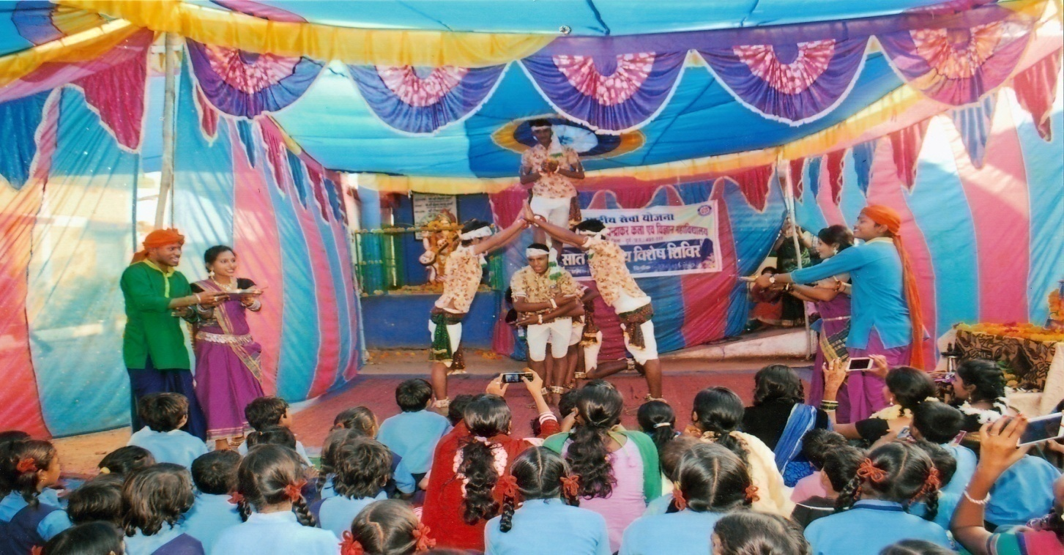
- A folkdance “panthi” by N.S.S. students of the college, held at camp-place village-borid, the.-patan
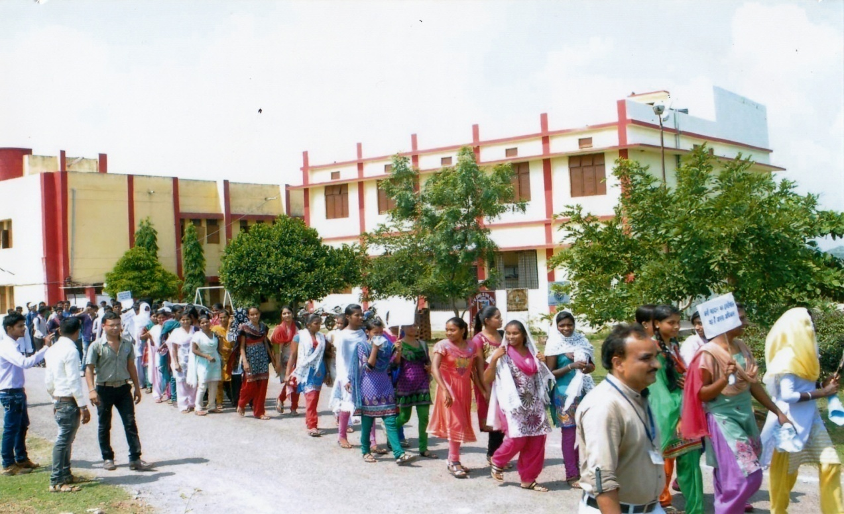

3. Prof. B. M. Sahu is guiding the rally of Gandhi Jayanti held on 02.oct.-2015, started from college. It gave message of cleanliness of campus.
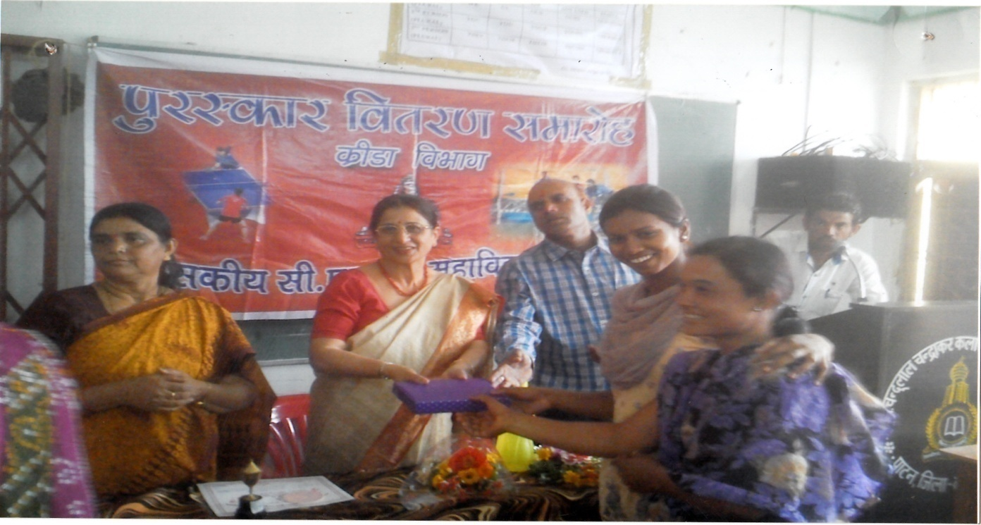

4. Principal Dr. (Mrs.) S. K. Bhardwaj is giving prize to sports girls of the college. Dr. D. K. Namdev, Dr. Shobha Srivastava and Student Union President Ku. Bhawna Dewangan are appearing in the photo.

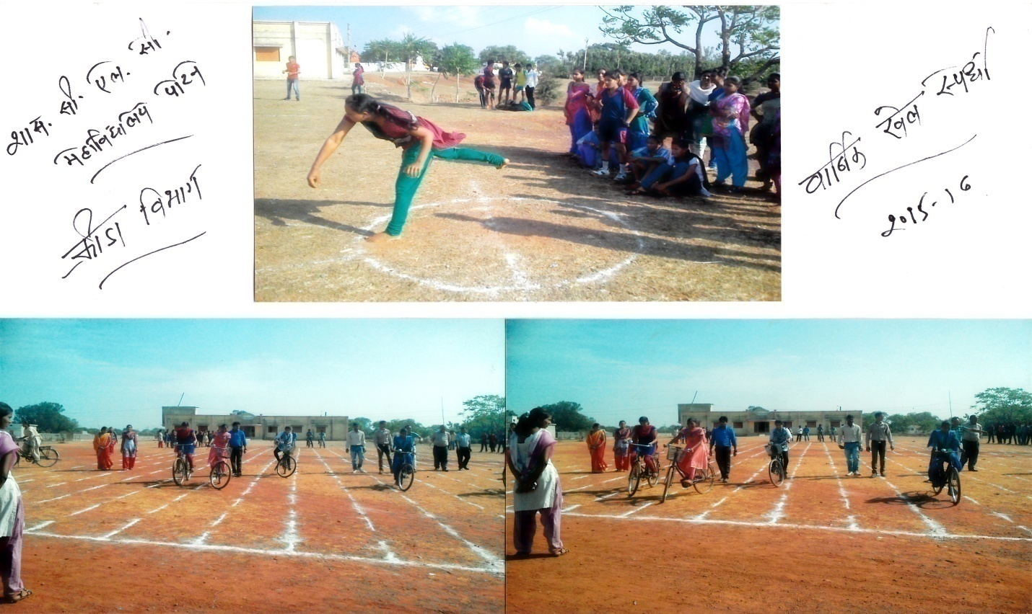
5. Annual Sports activity in college campus, organized by Dr. Dinesh Namdev, (Sports officer)

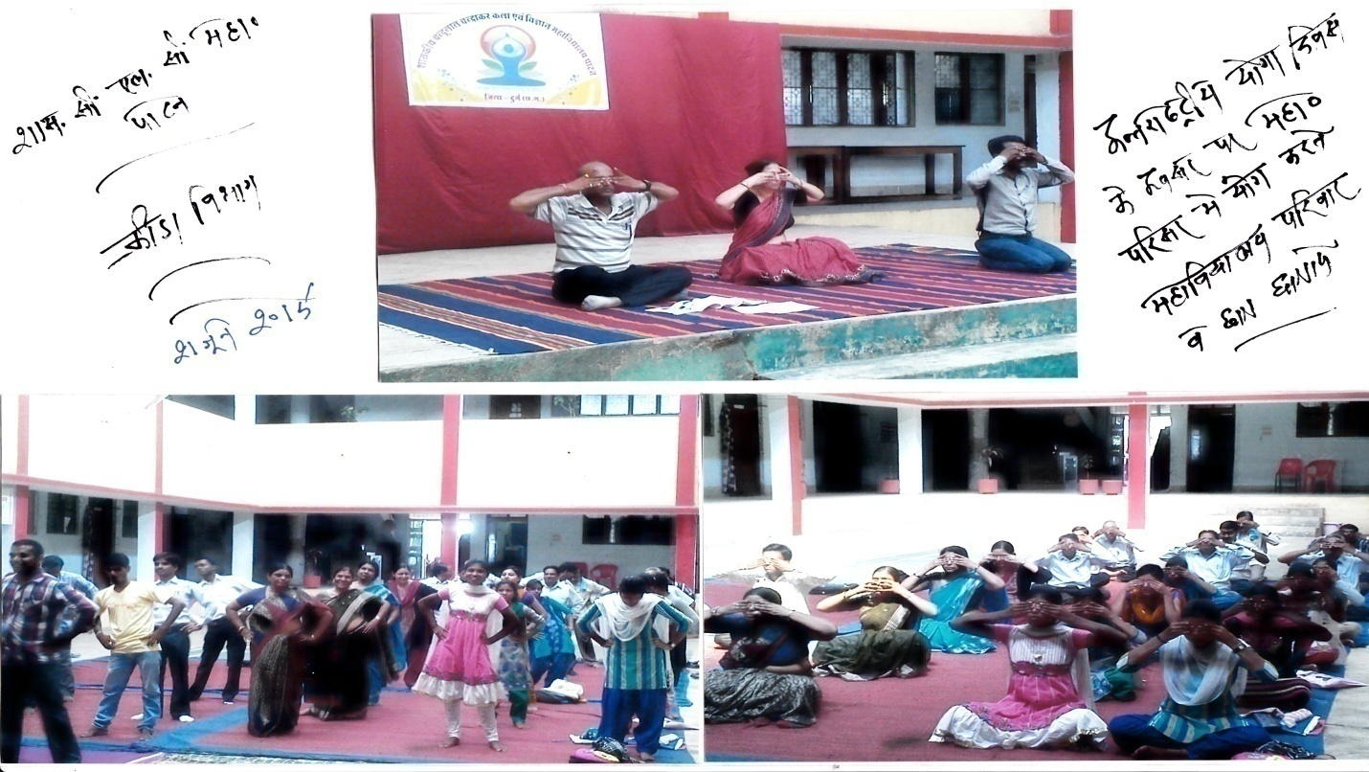5. First International Yoga day held on 21.06.2015 at College campus
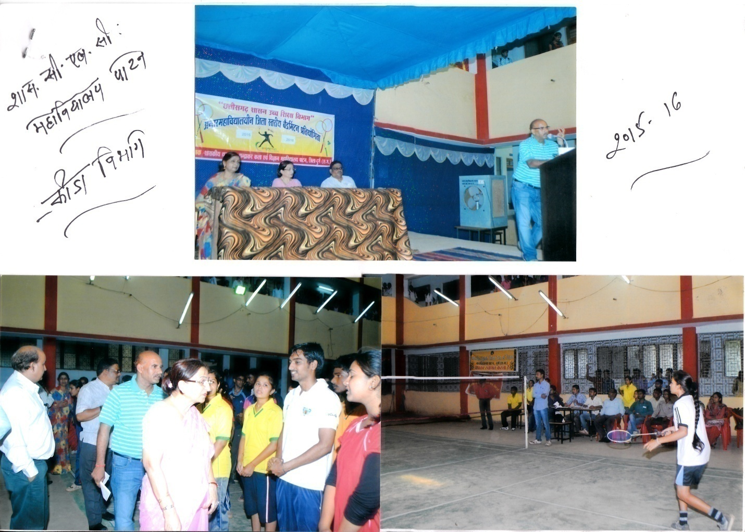6. Badminton competition of Durg district label college teams held at college.
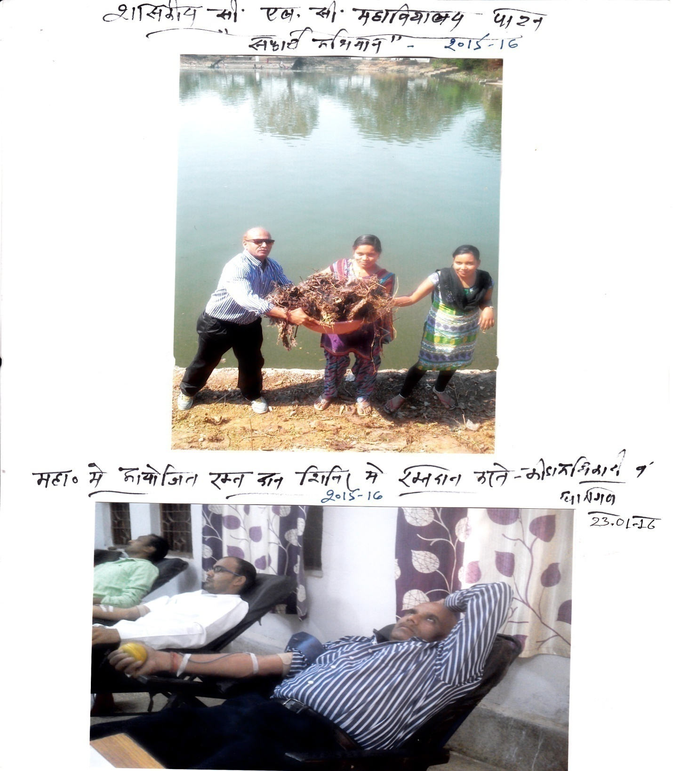
- (Above) Cleanliness program on college campus.
- (below) Blood-donation camp held on 23.01.2016 at college. Dr. Dinesh Namdev and students are giving their blood to Hospital.

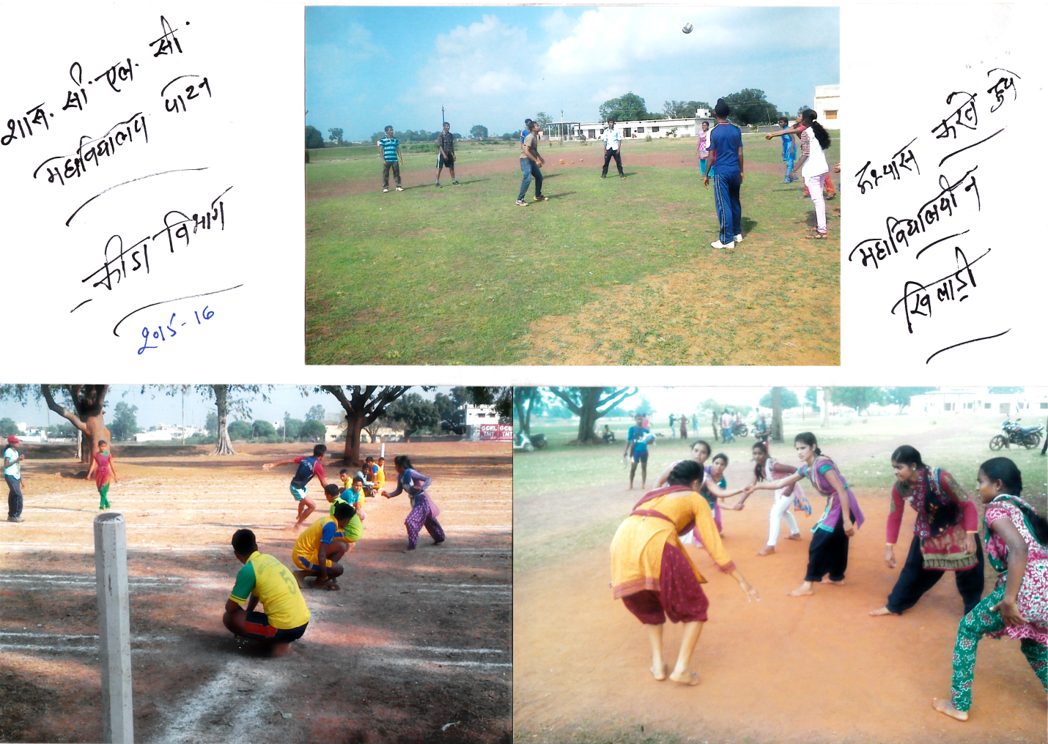
9-College students practicing Volleyball, Kho-Kho and Kabbaddi games in college campus.
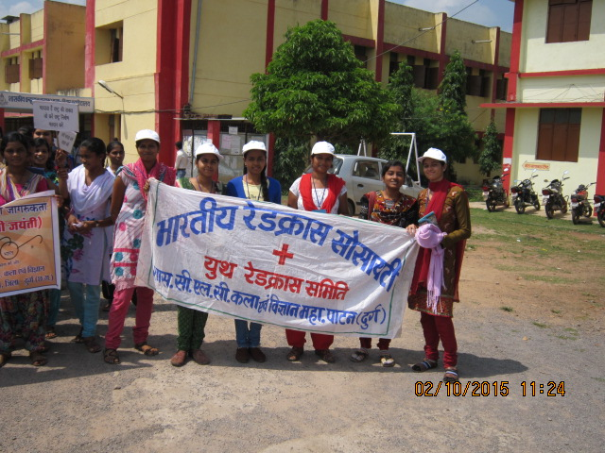
10-College Red-cross rally on 02.10.2015, headed by Prof. D. K. Bhardwaj

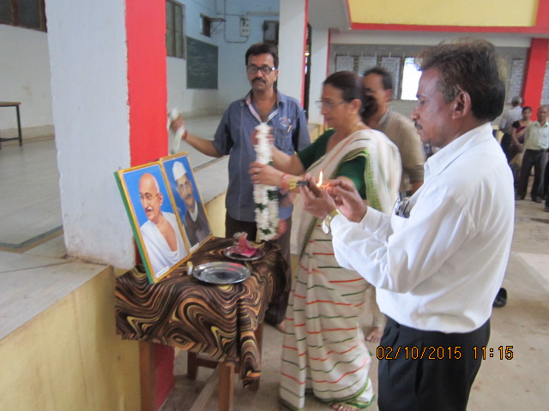
11-Principal Dr. S. K. Bhardwaj is worshiping Gandhi and Shastri Ji in the National cleaniness day 02.10.2015

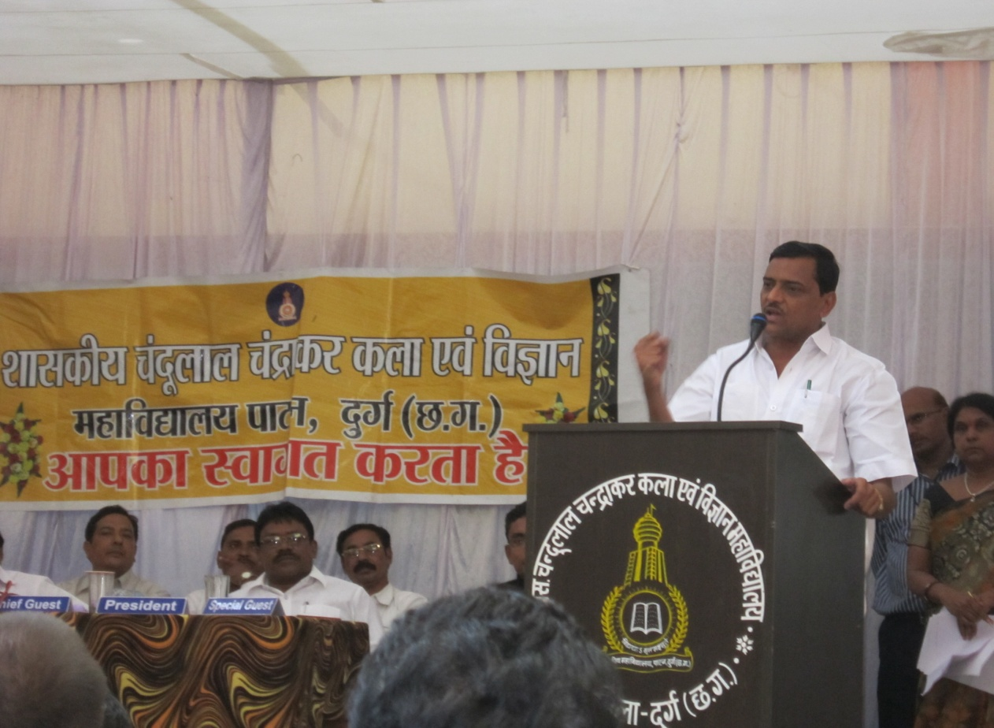
12. Minister Labhchand Bafna, MLA (Saja vidhansabha, CG) is addressing College student in the occasion of “Oath-taking ceremony” of student-union members-2015-16

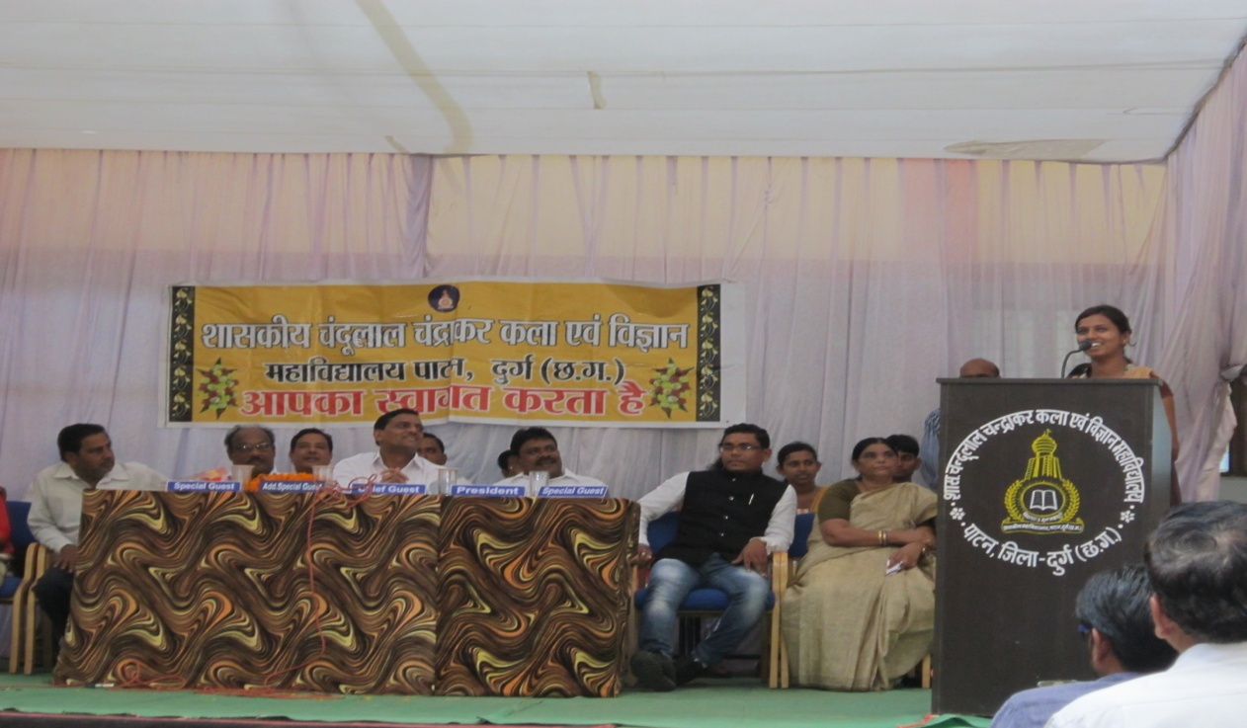
13. Ku. Bhawna Dewangan of B.Sc.-III make President of the STUDENT-UNION Election 2015-16. She is addressing students, after taking Oath.

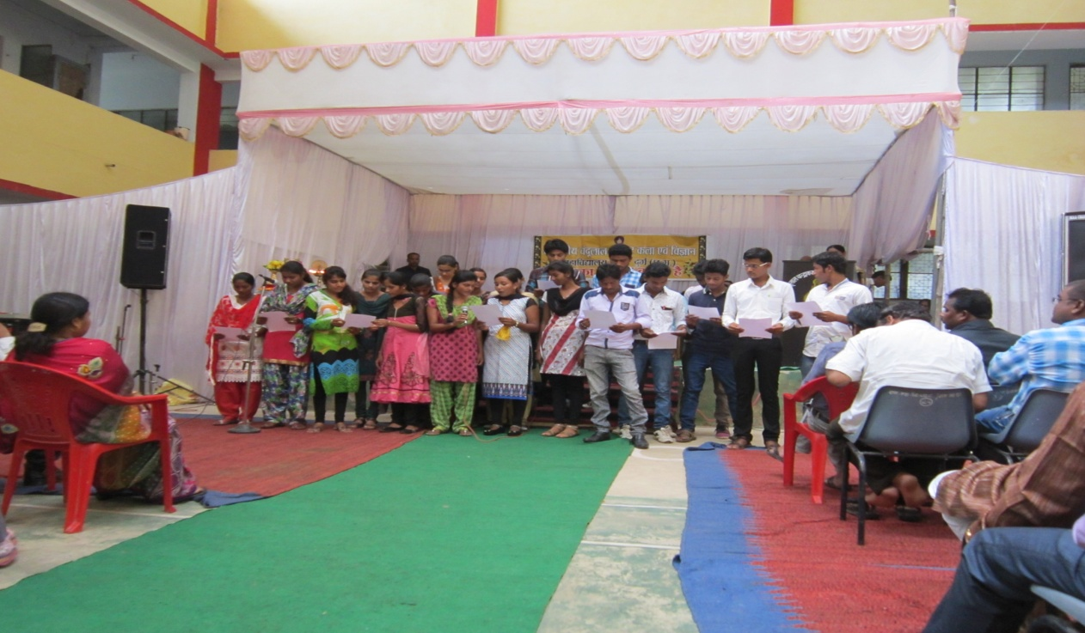
14. Oath taking ceremony for student election 2015-16

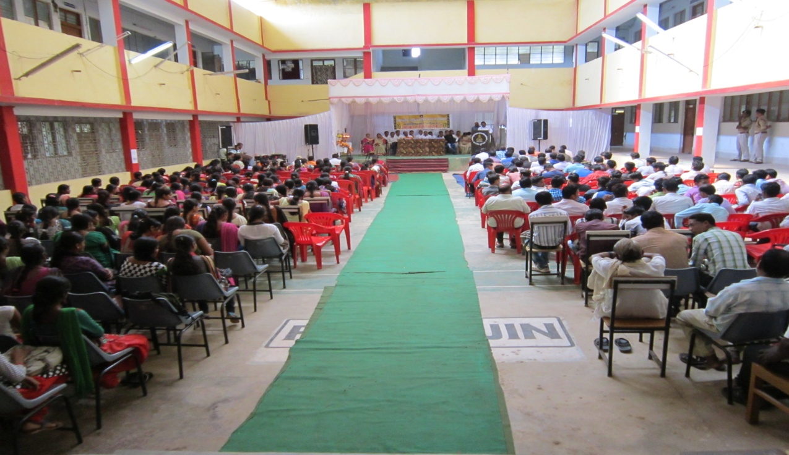
15. Front look of the Oath taking ceremony of student election 2015-16

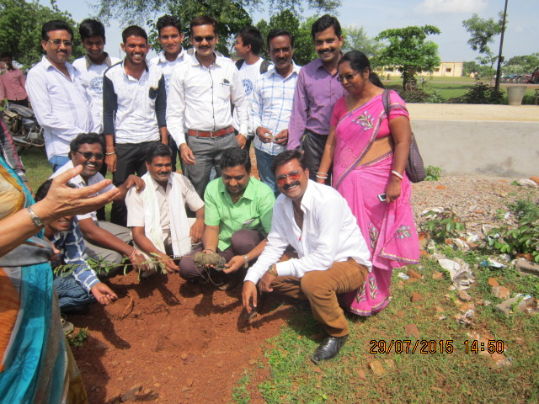
16. Tree plantation by NSS in 2015-16. Janbhagidari Samiti members of the college Sri Harsh Bhale, Sri Akhilesh Mishra, Sri Mohit Sahu, and others are taking part in this event.

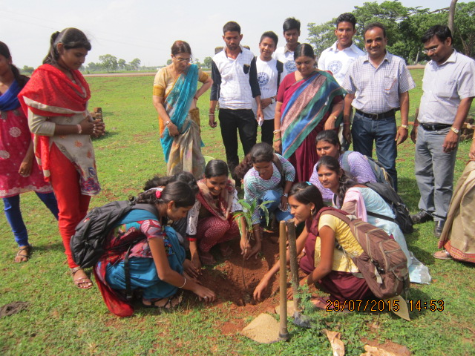
17. Tree plantation 2015-16. Dr. S. K.Bhardwaj, Shobha Srivastava, Prof. B.M.Sahu, Prof. Jagrit Kumar and Ex. Student and college students.

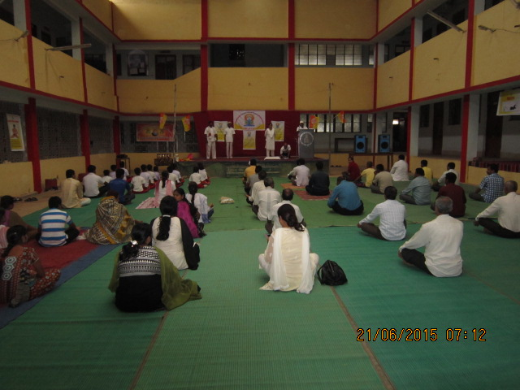
18. First Yoga Day celebration in the world held on 21.06.2016. Our college held it in the college campus.

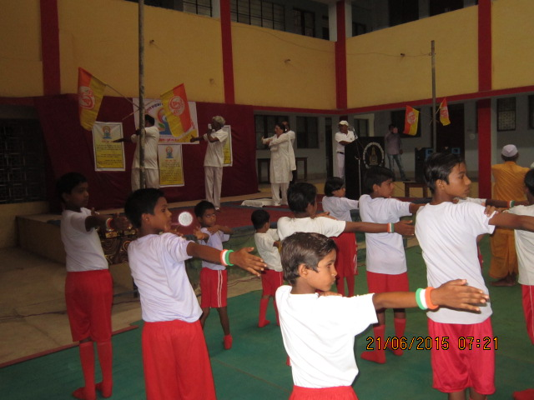
19. Students of “Yoga-school” Marra, with Yoga teacher Mr. Pushkar Verma take part in the college campus in the First Yoga Day Celebration in college.

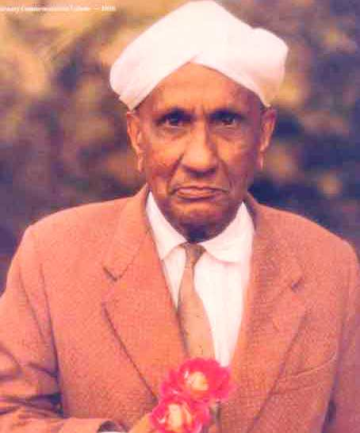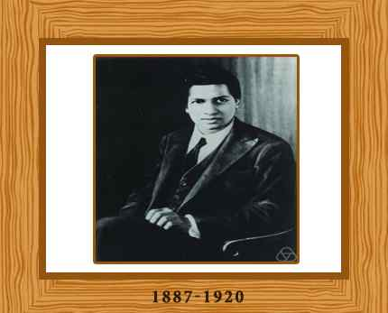
20. Science day celebration held on 29.feb 2016. Dr. R. K. Verma shown a power point presentation about the work of Dr. C.V.Raman(Nobel prize winner of Physists) and S. Ramanujan (Renowned mathematician of India).
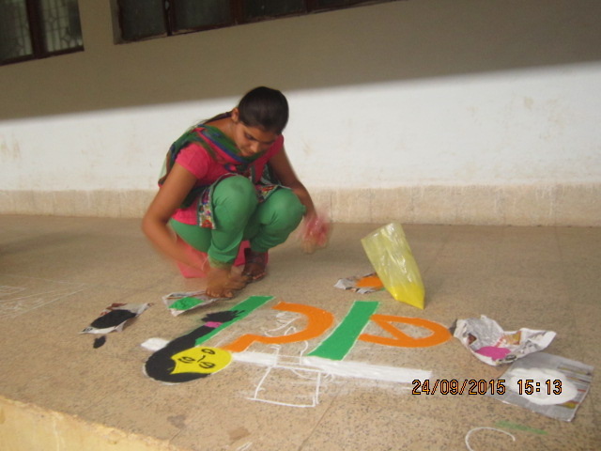

- Rangoli painting is being prepared to give message of “Save Girl child, Teach girld-child”

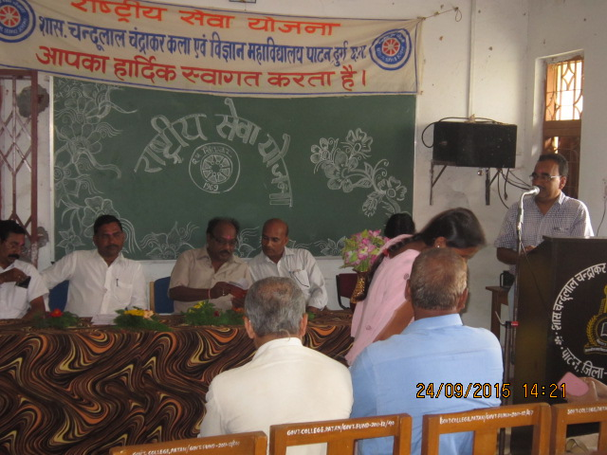
- N.S.S. day celebration on 24.09.2015. Prof. B.M.Sahu is addressing students of NSS. Dr. Dinesh Namdev, Sri Krishna Bhale (Ex. JBS president), Sri Damodar Chakradhari (Vice-president) and Dileep Sahu on front.
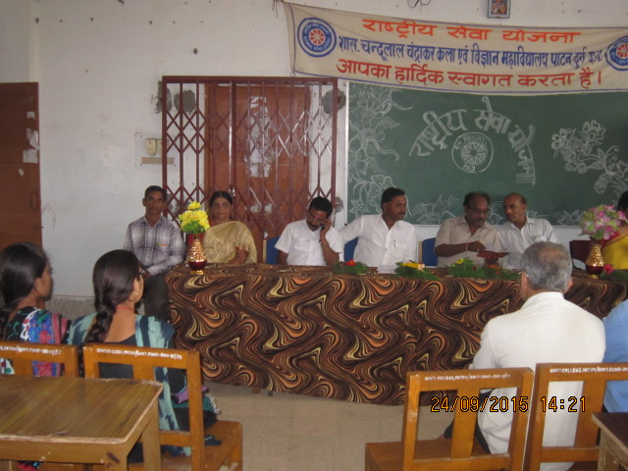
- Dr. Shobha Srivastava (incharge Principal) and Dr. R. K. Verma (co-ordinator, IQAC) were presented on the NSS day celebration held on 24.09.2015
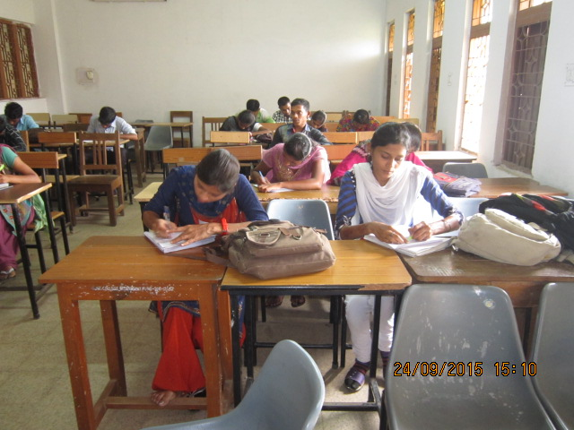
- Essay competition on the topic “Swachata aur paryawaran ”-Cleanliness and Environment organized by NSS.
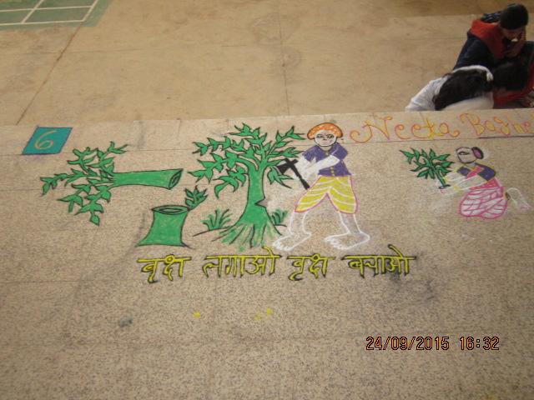
- Message of “grow tree, save tree” by Ku. Neeta Baghel under the RANGOLI COMPETITION organized by NSS on the NSS Day.
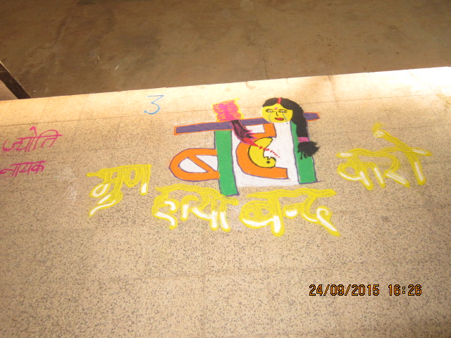
- A message of stop female feticide and save girl child, by Ku. Jyoti Nayak through RANGOLI COMPETITION.
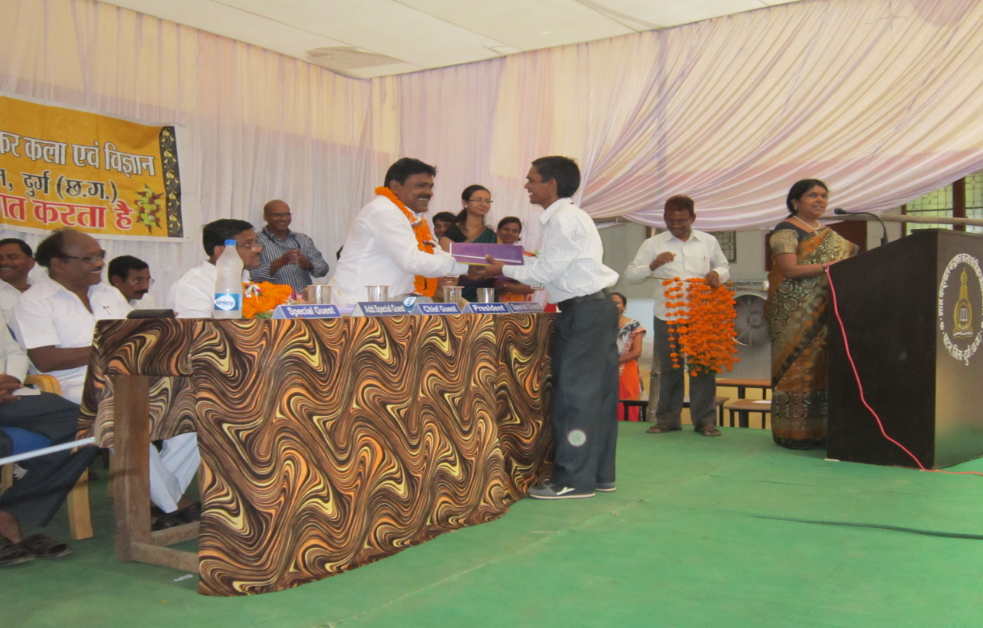
- IQAC co-ordinator Dr. R. K. Verma is welcoming Mr. Thanu Ram, member of District Panchayat Durrg on the occasion of Oath taking ceremony of STUDENT UNION 2015-16.
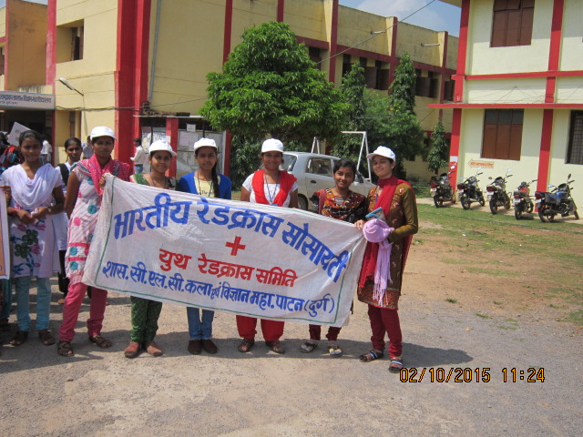
- A rally by YOUTH REDCROSS of Indian Red-cross Society Govt. college Patan is ready to release on the occasion of National Cleanliness day i.e., 02.oct. 2015. Prof. D. K. Bhardwaj is Red-cross incharge.
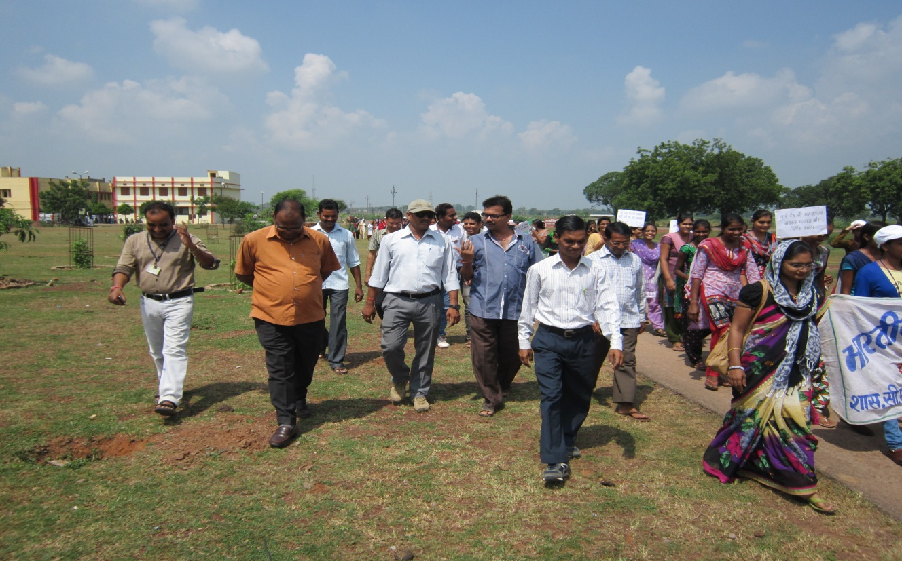
- This rally released from college (college building back) and visited Patan around
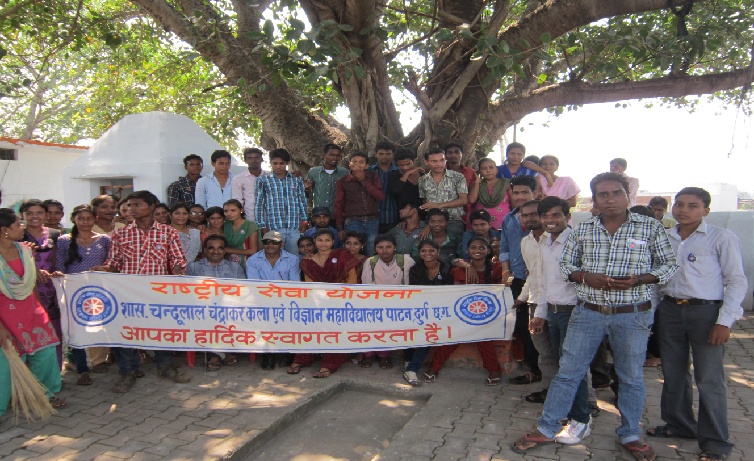
- A team of NSS student went to the campus of “Akhra Temple”. Prof. B. M. Sahu and Dr. D. K. Namdev headed to students of NSS.

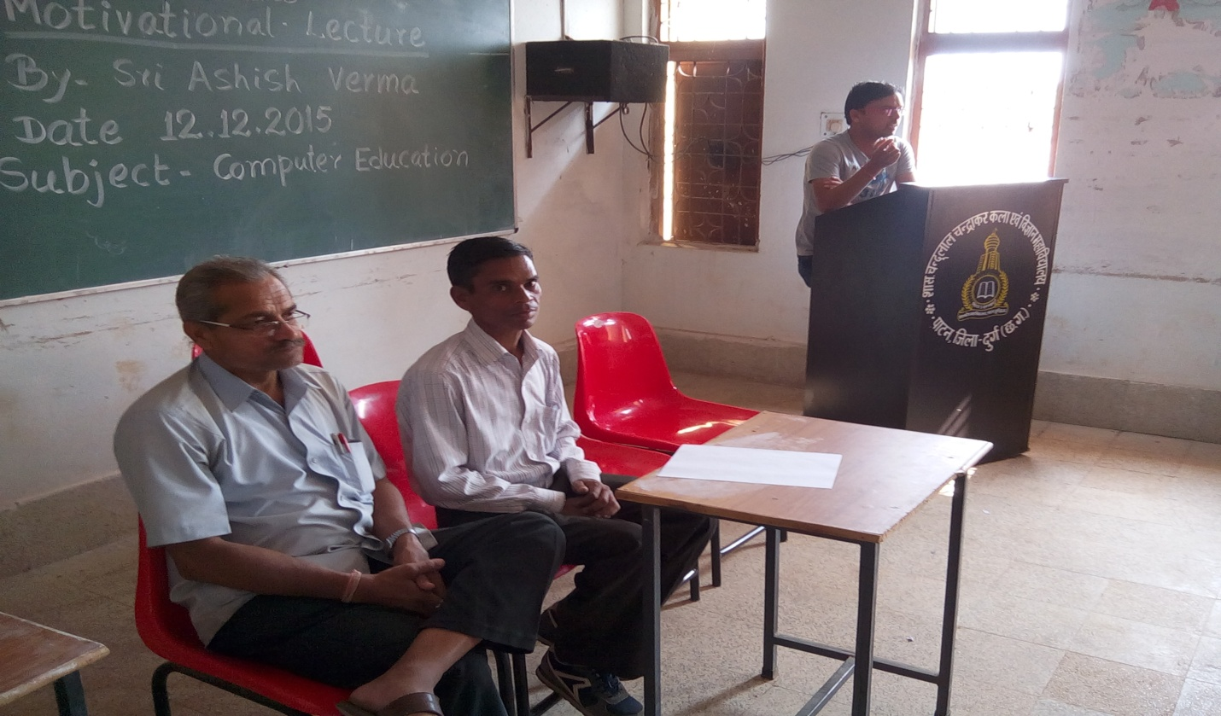
- Mr. Ashish Verma, Ex. Student and Computer expert addressing student of college about carrier in computer field.

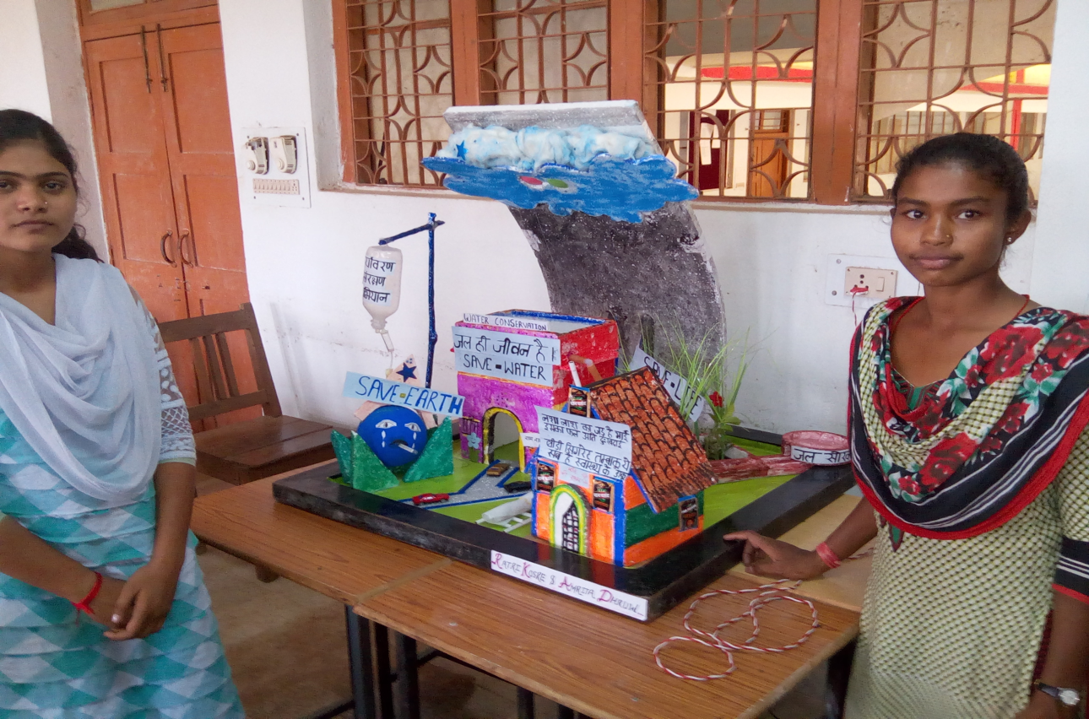
- A working model of “save water, save earth” in the science poster, model, competition on 12.12.2015

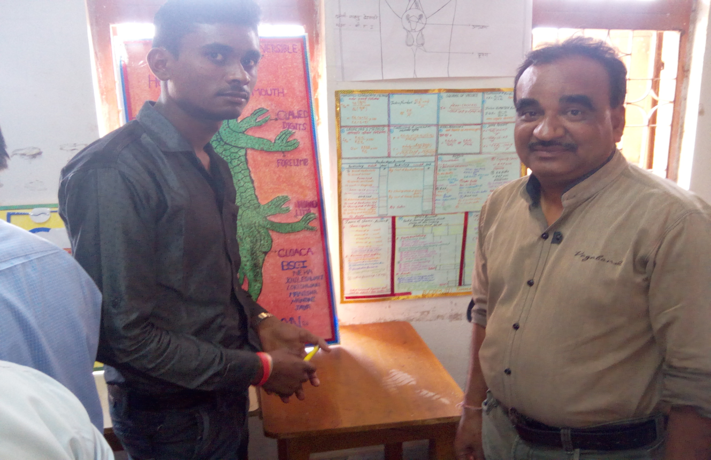
- Prof. B. M. Sahu is taking information about the poster presented in the POSTER COMPETITION 12.12.2015
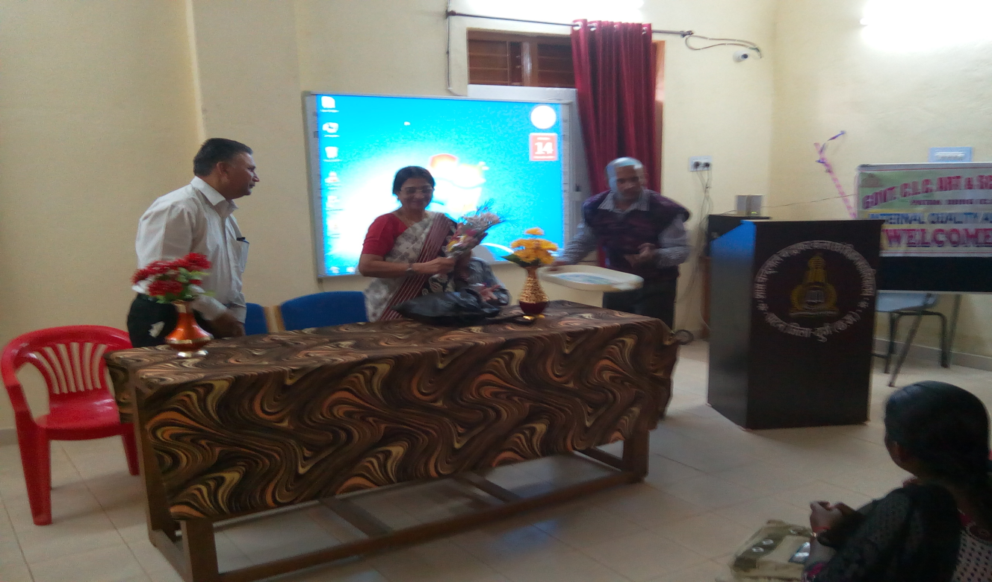
- Dr. Agashe HOD of Physical activity department, Pt. Ravishankar shukla University Raipur, Principal Dr. (smt.) S. K. Bhardwaj and Dr. Dinesh Namdev (sports officer), in the eve of Guest lecture by Agashe
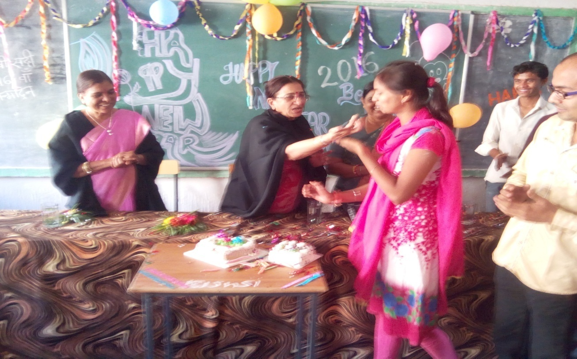
- Happy New year celebration on 01.01.2016 held at Govt. college patan; Principal, staff and students.
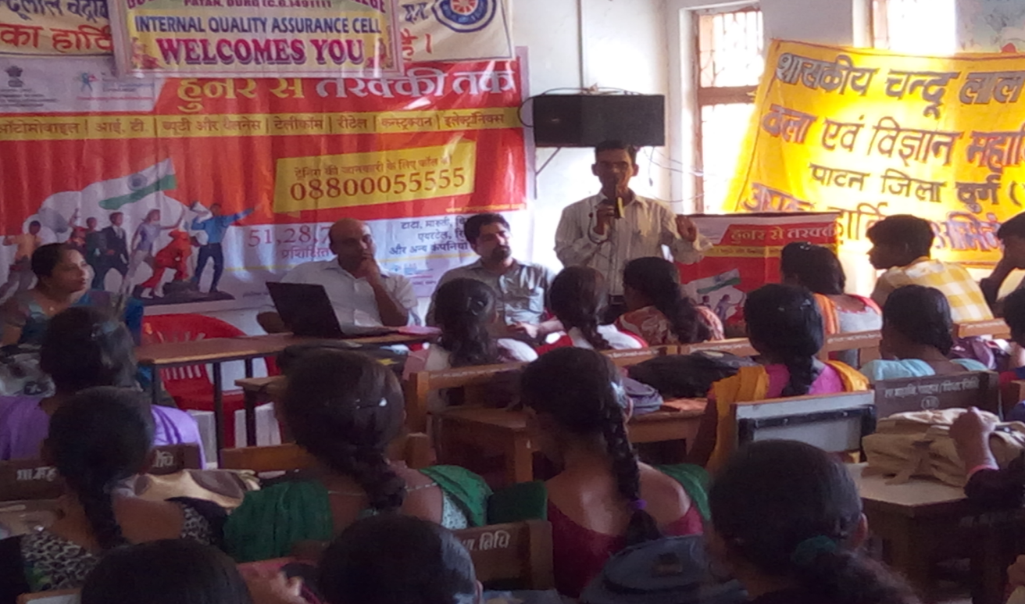
- Carrier seminar held by NSDCL at Govt. college Patan
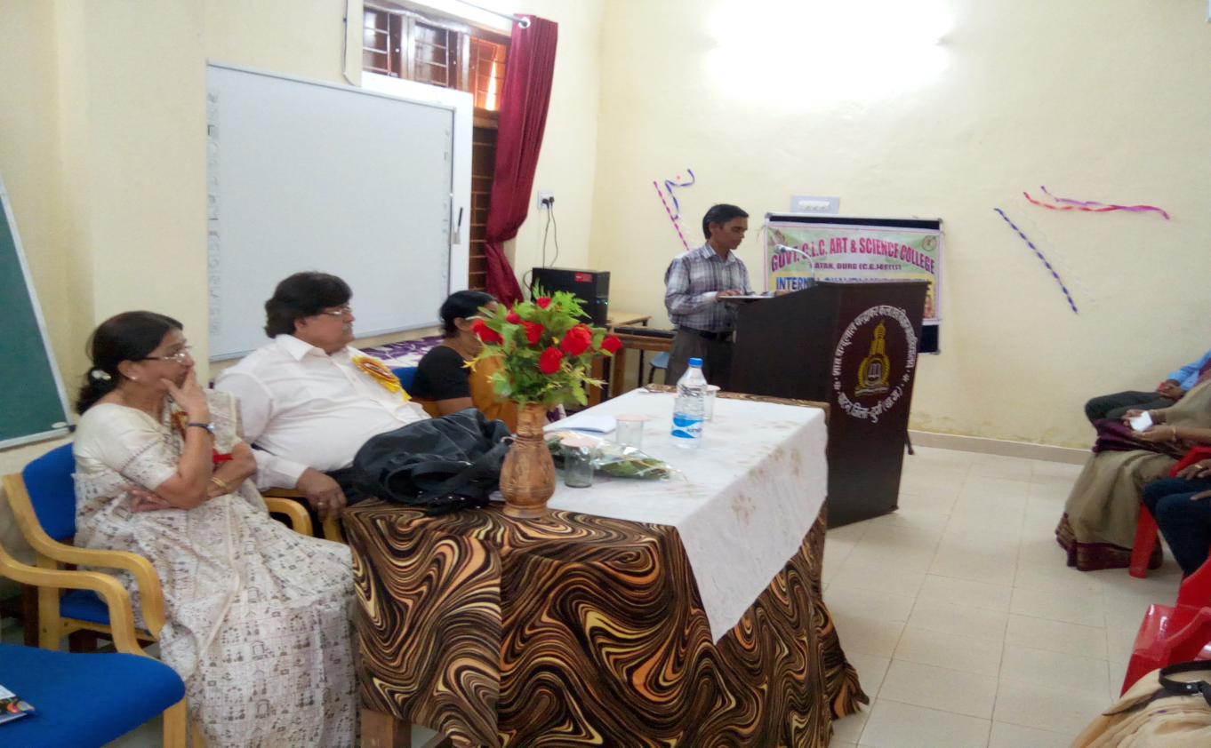
- Sri M.M. Srivastava and Principal Dr. S. K.Bhardwaj. Prof. (Dr.) R. K. Verma is addressing student in the occasion of Guest lecture on “Personality development”on 29.10.2015
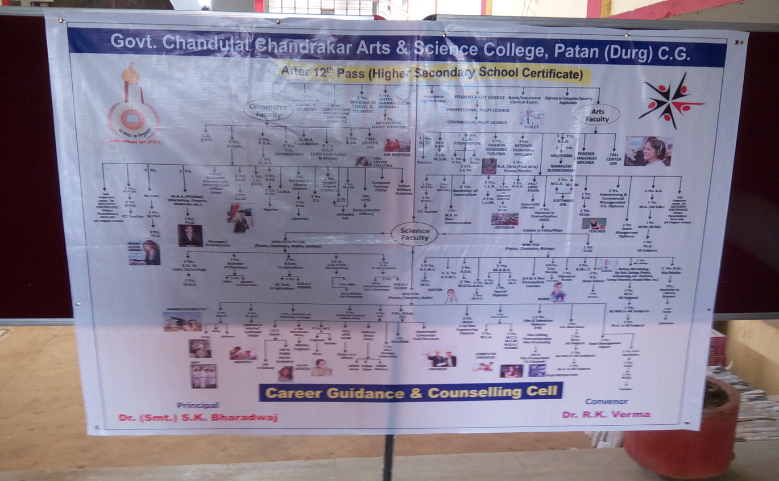
- Carrier poster on “what to do after class 12th ” a flow chart inaugurated by Dr. R. K. Verma and Principal Dr. S. K. Bhardwa

